Project title: “Strengthening the SMEs’ professional contacts in the field of dual training in the V4 countries”
Project partners:
- Hungary - IPOSZ Budapest, coordinator,
- Czech Republic - AMSP ČR Praha,
- Poland - ZRP Krakow,
- Slovak Republic - SŽZ Bratislava

The summary of the Slovakian/Czech/Polish/Hungarian workshops
The project called „Strengthening the SMEs’ professional contacts in the field of dual training in the V4 countries“, follows a previous Small project where the project partners implemented a V4 conference in March 2015, on the actual situation of dual education in the craft sector.
This project, which has been initiated by IPOSZ, the Hungarian Association of Craftsmen’s Corporations and considered to receive a standard grant from the Visegrad Fund, is coordinated by IPOSZ itself.
The project partner organizations are: AMSP-ČR, Association of Small and Medium-Sized Enterprises and Crafts of the Czech Republic from the Czech Republic, ZRP Malopolska, Małopolska Chamber of Craft and Entrepreneurship from Poland, SŽZ, Slovak Craft Industry Federation from the Slovak Republic.
The main objective of this project was to organize a two-day workshop in every V4 country in a given profession. These professions were: metal industry in Hungary, construction in Poland, wood industry in the Slovak Republic and glass sector in the Czech Republic. A 3-person trade delegation took part at each workshop from every participating V4 country. Every delegation consisted of a craftsman, who provides practical training and bearing a leadership position in the professional association; a teacher from a vocational school, where theoretical and supplementary practical training is provided and a representative of the participating SME associations, who takes care of relations in the field of dual training.
In a separate chapter, we will present the programs and the photo documentation of these workshops, in details.
Another objective of the project was to prepare a summary after the workshops, containing the delegations’ experiences.
Another objective of the project was to list 5 companies and 2 vocational training schools in every profession from every V4 countries, which are interested in keeping contact with such companies and vocational schools from other V4 countries which could be the base of professional contacts and further cooperation in the future in professional topics or/and in the field of dual vocational training, as well.
In addition, all participating organizations designated one of its staff members, who would take care of the professional contacts in the future.

Experiences of the workshops
After the workshops in every profession from each V4 country, the school representatives and entrepreneurs reported their experiences, and what they gained during the workshops.
Before the workshops, the four organizations worked out basic orientation questions jointly, along which the summaries were prepared. These orientation questions were:
In your profession
- What is the situation of the dual training in your country?
- Are there enough young people who are interested in learning the given profession?
- What is the proportion of the theoretical and practical training in the curricula of the profession? Is it proper? Is it satisfactory? In what ratio does the practical training take place in the school workshop and in what proportion in the enterprise?
- Are the enterprises involved in practical training?
- Are all conditions assured of keeping apprentices in the company? If not, which pre-conditions are missing?
- Are there enough practical trainers (instructors) in the schools?
- Are there adequate modern facilities, including IT tools in the schools and at the companies in order to train the profession at European level?

According to the detailed answers given by the entrepreneurs and school representatives, a general summary has been compiled, which you can read in the followings.

Summary, experiences of the workshops
If we want to deepen the comparison of the dual training systems of the Visegrad countries, this should be carried out with the involvement of much more professional force. The training systems in the four Visegrad countries show significant differences, starting from the interpretation of the vocational training support schemes to the relationship between the vocational training institutions and the enterprises.
In every country, all the investigated 4 professions consider it particularly important to move forward in the direction of dual training, as well as the accomplishment of as many as on-the-job practical trainings as it is possible. This is especially true for the SME sector, for the family and the micro enterprises, as well. The governments of each country apparently strive to move in this direction, in Poland and Hungary it shows a more constant improvement, than in the Czech Republic and the Slovak Republic.
However, currently in the Czech Republic and the Slovak Republic the reality is that the micro and small enterprises are involved in the practical training only to a limited extent. The professional training is implemented mainly by the schools in their own workshops, and the proportion of practical training is only barely over 50%. Apart from Poland, in the other V4 countries, there is no student-contract system exists, that exists in Hungary. The Hungarian model has the advantage of a vocational training fund, from which the companies can finance the costs of practical training, regardless of whether they are large or small companies.
In other V4 countries, the companies are entitled to a considerably huge amount as a compensation of their training costs, but only at the end of the training, when their student passed the vocational final exam successfully. It can be said that the V4 countries regarding to the interpretation of the concept of dual training do not use the same interpretation as the German, Austrian and Swiss system use, but they try to move in that direction. Hungary and Poland is a bit closer to that interpretation, the Czech Republic and the Slovak Republic are a little farther.
It seems to be a general problem that in each V4 country, the practical training still takes place in the school workshops prevalently. It is also a common problem, that the proportion of practical and theoretical training had not reached the desirable 70-30% ratio, and therefore, the effectiveness of the practical training is still doubtful, according to the employers.
It could be concluded that in the practical training modern machines and equipment are used, but the SME sector finds it difficult to follow the requirements of the IT revolution as well as 4.0 economy; and this is true for the instructors as well, who deal with students in the school workshops.
It is general, that in some professions, especially in practice-oriented ones the number of young people who are interested in learning that certain profession is decreasing. It is not only an economic, but also a social and education policy issue which affects all V4 countries similarly.
In the Czech Republic, the formation of dual training seems to be half-way to completion, the agreement system between schools and companies providing practical training has already existed. The companies’ training providers keep contact with the vocational schools, but the student contract system is not yet as advanced as in Hungary. However, there is a significant demand on moving in this direction. Anyhow, it is a fact that the school workshop system is still very strong, it performs well and the school workshops are very well-equipped.
Entrepreneurs argue that only few companies are still in regular contact with the vocational schools.
The relationship between companies and schools is a particularly important element of the dual training. In the V4 countries this relationship could be characterized by school dominance deriving from legal decrees, at the same time, in the significant number ofthe Western European countries, the real economy has a much more prominent role in this relationship.
In every country and every profession, a basic question that arises is to what proportion of practical training goes on in the school workshop and to what proportion it does in the companies. After all, it determines whether we can talk about real dual training or not. In this respect, the V4 countries lag behind the German, Austrian and Swiss practice.
It should be noted that concerning the concept of dual training, there are various interpretations within the V4 countries. It is considered dual training also when, on the basis of an agreement with an enterprise a school sends its students to the enterprise for practice, for a certain period of time. It should be emphasized, that, in in the German, Austrian and Swiss dual training models, young people spend their greater part of training time at companies and plants. The economy decides on the direction of the training, on the professional content of the training in close cooperation with the schools. Many countries, including the Czech Republic and the Slovak Republic among the V4 countries, do not interpret so the dual training. In Poland and Hungary there are also different interpretations in comparison to the three countries mentioned above, which are mainly based on focusing more on schools.
During the last period, the number of young people who want to learn craft trades decreased, although, the companies offer jobs for the graduates where the income opportunities are not bad. Of course, in the four countries there are totally different incentives and financial support schemes operating in these areas.
In the V4 countries, the hourly wages of skilled workers are different. For example, in the Czech Republic, compared to the Hungarian situation, the hourly wages are significantly higher.
In some V4 countries, the decline in the interest in the craft industry could be linked to a faulty export policy, that distributes mainly large-scale machine-made goods and does not seek to create a market for sophisticated craft products.
The reflections of the vocational schools in the Czech Republic and the Slovak Republic show that they want to implement the apprenticeship mainly in partnership with larger enterprises. This opinion shows that there is quite a deficient relationship between vocational schools and micro and family companies, or if there is, it is not systematic.
There is little chance for professional guidance done by companies in the primary schools, where the companies could have direct access to the young interested people. In the companies, there are a lot of well-paid vacancies, but now in the last 1-2 years, there is a shortage of professionals. It is hoped that this trend will reverse, and the high school graduates will start to learn professions and the adult education should also involve the older generations in a greater extent, in order to solve the problem of human resource shortages.
In the traditional form of education, at both the companies and schools, all the necessary devices are available. However, especially for micro and small enterprises, it will be very difficult to follow the new challenges of the IT revolution and the transition to the 4.0 economy, this is why the governments should continue their investment in incentives.
We can conclude that in the V4 countries the majority of older, experienced specialist teachers will retire in the near future, and young teachers either do not have the proper technical knowledge and expertise, or they do not come at all, because of low teacher salaries. So clearly, there is a lack of teachers in vocational training institutions.
Schools try to solve this problem in such a way that they temporarily invite experienced professionals, trainers from companies to school workshops.
It seems to be a large problem that, regarding to the use of modern information systems, there has been a gap generated between the different generations of teachers; and because of the rapid development of the 4.0 economy, later on this situation will become even more serious. Therefore, in each V4 country, every profession should deal with this topic, particularly in the area of ​​family and micro enterprises.
It can be concluded that according to the opinion of the companies, in these professions there is not enough practical training provided, especially, there is not enough practical training taking place in the enterprises. On the other hand, the schools argued that the ratio of theoretical and practical training is appropriate.
In the four countries and all the examined professions, it is general that the salary of the trainers teaching in schools is significantly lower than the salaries paid in the real economy, such as at companies, and therefore, it is difficult to employ experienced people bearing the appropriate practical skills in schools.
Generally, we can conclude that the companies, which provide practical training do not have all the machines and pre-conditions that are required by the curriculum. Therefore, every country looks for ways how a third, an additional pillar could be established in the system, besides the school workshops and the companies where additional practical training could be implemented (e.g. practical training centers over the plants).

Workshops’ syllabus and photo documentation
- Wood industry workshop in the Slovak Republic
The first workshop was carried out in the Slovak Republic between 20—21April 2016, organized by the Slovak Association of Crafts, (Slovensky Živnostenský Zväz),for the timber industry. On the first day, the representatives of professional organizations, entrepreneurs and vocational school experts from the four countries visited a Slovak vocational training school, and took part on the practical training of small companies. On the second day, more vocational and practical training sites were visited and a meeting was conducted between representatives of the professional associations of the four countries. See the program of the workshop and photo documentation of the meetings below.
The Program of the wood industry workshop in the Slovak Republic
Date: 20—21.04.2016
Venue: Slovakia, Nové Zámky, Topoľčany

20.04.2016 (Wednesday) - Topoľčany
07,00 – 08,00 hod. – breakfast, Hotel Korzo
08,00 – 9,30 hod.– journey to the city of Topoľčany (ca 80 km from Nové Zámky)
10,00 – 12,00 hod. – visiting a vocational training school, Stredná odborná škola drevárska (Secondary Wood Vocational School), Pílska 7, 955 01 Topoľčany,
Contact: Mgr. Miloš Bobula, school director,
telephon Nr.: +421/38 53 63 211; e-mail: sekretariat@sosdrevarska.sk;
12,00– 12,30 hod –press conference, Stredná odborná škola drevárska (Secondary Wood
Vocational School), Pílska 7, 955 01 Topoľčany,
12,30 – 13,30 hod. – lunchin Topoľčany
13,30 – 16,30 hod. – visit 2 small enterprises, which provide dual training;
16,30 – 18,00 hod. – return to Nové Zámky
19,00 hod. – dinner and informal evaluation of the day (Hotel Korzo);

21.04.2016 (Thursday) – Nové Zámky
08,00 – 09,00 hod. – breakfast, Hotel Korzo
09,30 – 12,30 hod. – visit 1-2 small enterprises, which provide dual training, Nové Zámky
12,30 – 13,30 hod. – lunch
14,00 – 17,30 hod. – school visit + have a meeting with the V4 professional organizations
Stredná odborná škola stavebná (Secondary Construction vocational School), Nitrianska cesta 61, Nové Zámky;
Contact: Ing. Štefan Száraz, school director
Telephon Nr.:+421/905503142; e-mail: szaraz@centrum.sk
18,00 hod. – dinner and informal evaluation of the workshop (Hotel Korzo);

Local organiser: Viola Kromerová, Secretary General
Slovenský živnostenský zväz (Slovak Craft Industry Federation)
Račianská 71
831 02 Bratislava 3

Mobil: +421-911-249 157
Telefón: +421-2-49 24 62 34
Fax: +421-2-49 24 66 53
E-mail: sekretariat@szz.sk or kromerova@szz.sk
Web: http://www.szz.sk

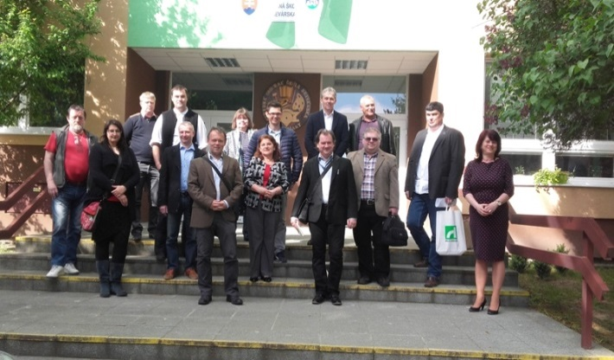 | 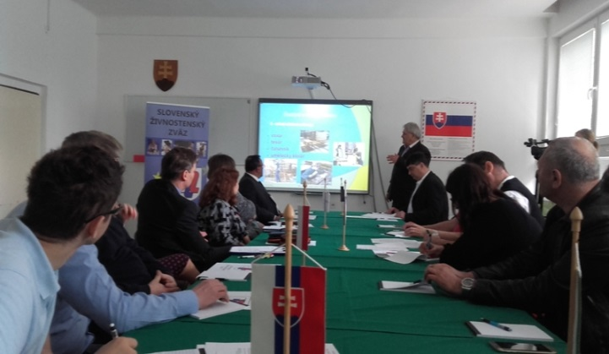
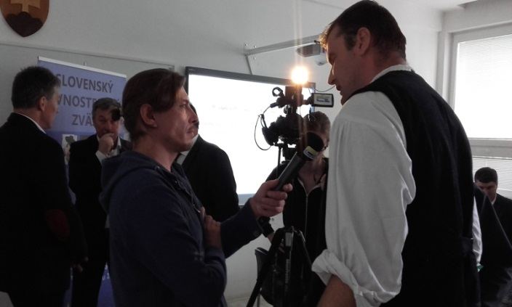 | 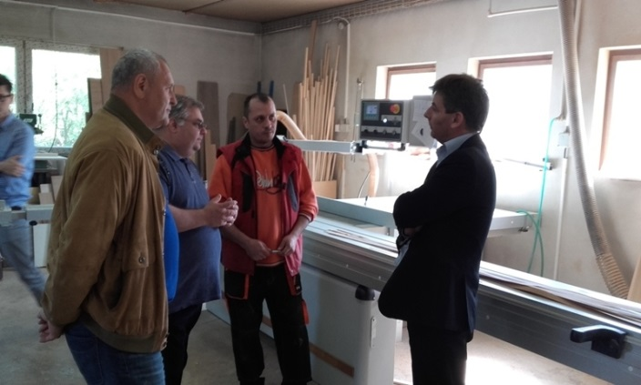
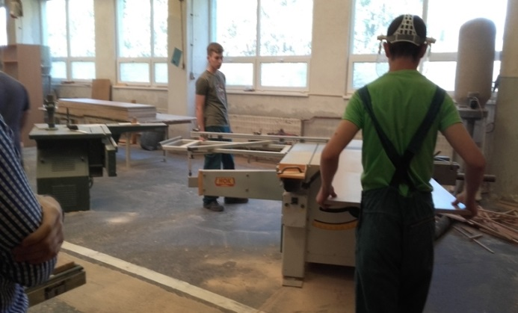 | 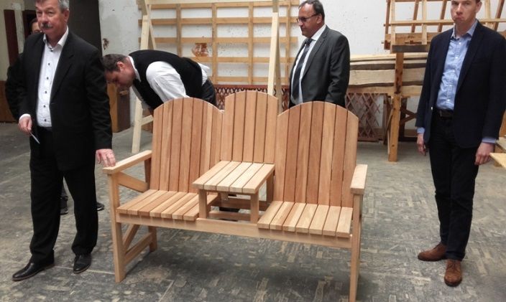
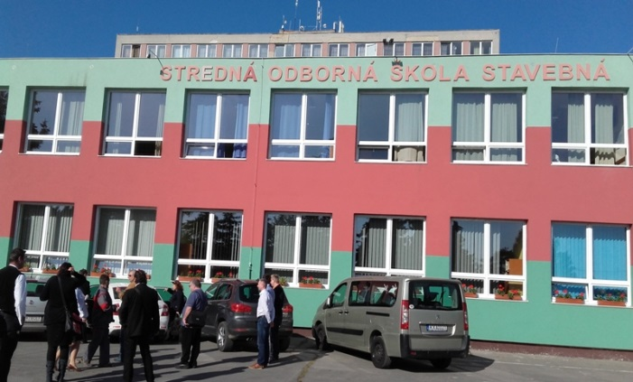 | 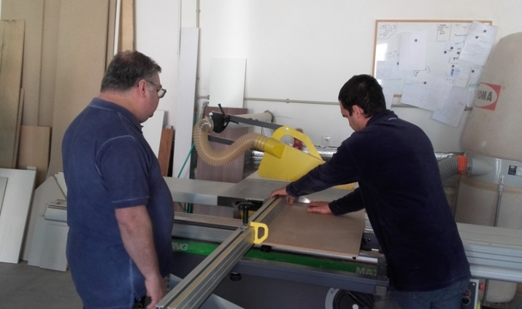
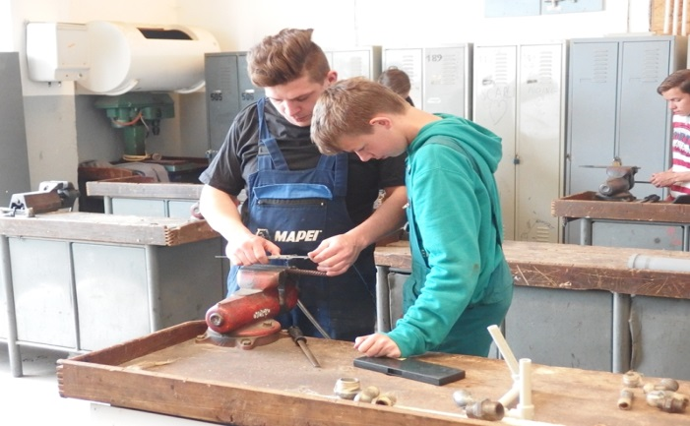 | 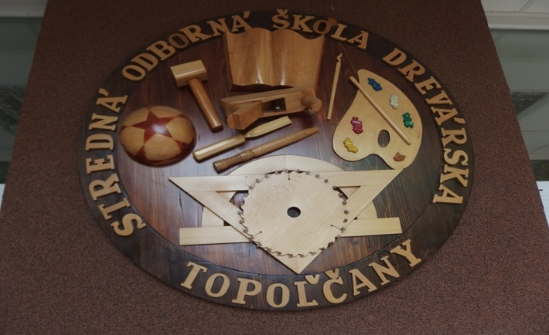

- Glass sector workshop in the Czech Republic

The second workshop was carried out in the Czech Republic between 04—05. May 2016organized by the Association of Small and Medium-Sized Enterprises and Crafts of the Czech Republic, (Asociace malých a středních podniků a živnostníků České Republiky, AMSP ČR), for the glass sector. On the first day, the representatives of professional organizations, entrepreneurs and vocational school experts from the four countries visited a Czech vocational training school, and took part on the practical training of glass companies. On the second day, more vocational and practical training sites were visited and a meeting was conducted between the representatives of the professional associations of the four countries. See the program of the workshop and photo documentation of the meetings below.

The Program of the glass sector workshop in Czech Republic
Date: 04—05. May 2016
Venue: The Czech Republic: Varnsdorf, Nový Bor, Podebrady, Praha

04.05. 2016 (Wednesday) –Varnsdorf, Nový Bor, Podĕbrady, Praha
07:00 – 08:00 – breakfast,Hotel Varnsdorf
08:00 – 08:30– journey to the city of Nový Bor (cca23 km from Varnsdorf)
08:30 – 10:00 – visit + workshop at Glass School,NovýBor(Wolkerova 316, NovýBor)
Contact: PaedDr. Ilona Jindrová, director,
telephone no.: +420 487712 212; e-mail: jindrova@glassschol.cz
10:00– 11:30 – journey to the cityof Podĕbrady (cca 90 km from NovýBor)
11:30 – 12:30 –visit + workshop atBlažek GlassPodĕbrady (Olbrachtova 600/II, Podĕbrady)
Contact: Ing. Lenka Zdobinská, executive director
telephone Nr.: +420 325 603 210; e-mail: secretary@blazek-glass.cz
12:30 – 13:30 – lunch in Podĕbrady,
13:30 –15:00 – visit +workshop atCrystal BohemiaPodĕbrady (Jiráskova 223/19, Podĕbrady)
Contact: Ing. Jaroslav Seifrtjr., director
telephone no.: +420 325 602 217; e-mail: company@crystal-bohemia.com
15:00 – 16:00 – journey to Praha (cca 50 km from Podĕbrady), accommodation
17:00 – 18:00 – workshop meeting with the V4 professional organizations at hotel

05.05.2016 (Thursday) – Praha (all transfers by public transport)
10:00 – 12:30 – visit Středníškolatechnická (Zelenŷ Pruh 1294, Praha)
Contact: PaedDr. Ivana Nechvátalová, Head of the education of adults, projects and grants
Tel.: +420 605 388 098
e-mail: inechvatalova@zelenypruh.cz
12:30 – 13:30 – lunch at Střední škola technická
14:00 – 15:30 –visit of Moser Gallery and shop(Na Příkopé 12, Praha)
17:00– 19:00 – common dinner with the Chairman of the Board of AMSP ČR (Karel Havlicek) and president of glass sector professional association Czech Art of Glass +informal evaluation of the workshop

Local organizer: Markéta Šandová, Project manager
Association of Small and Medium-Sized Enterprises and Crafts of the Czech Republic (AMSP ČR)
Sokolovská100/94
186 00 Praha8 - Karlin

Mobil: +420-733-722512
Telefón: +420-236 080454
E-mail: sandova@amsp.cz
Web: http://www.amsp.cz

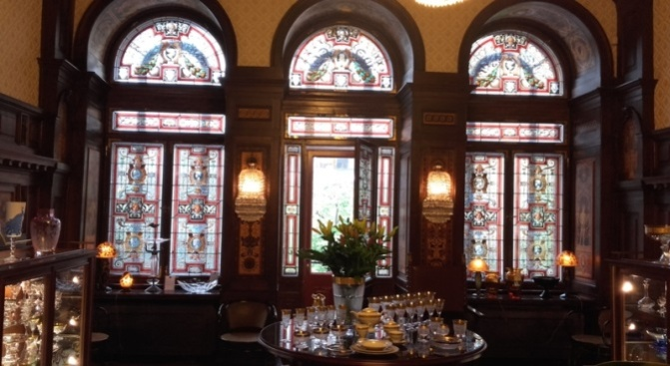 | 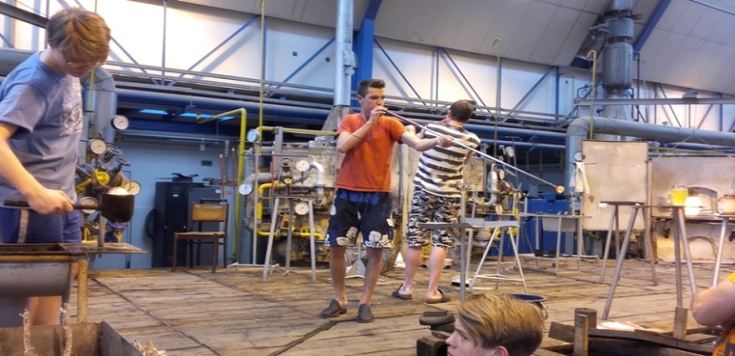
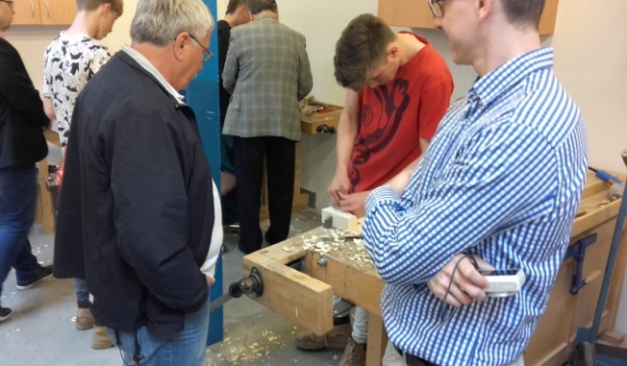 | 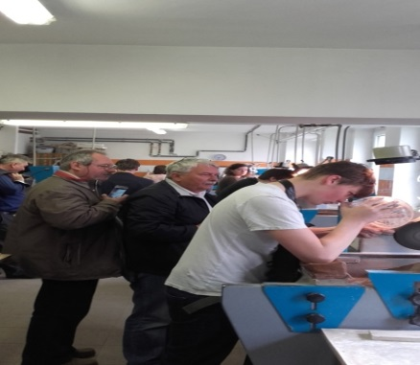
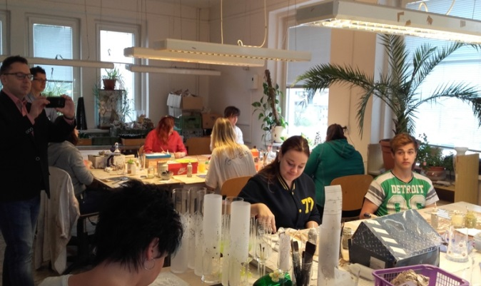 | 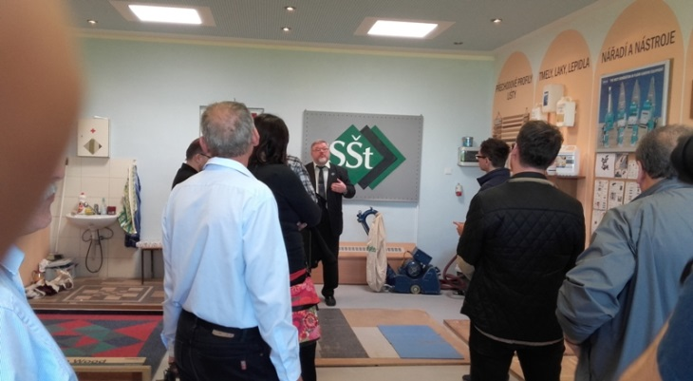
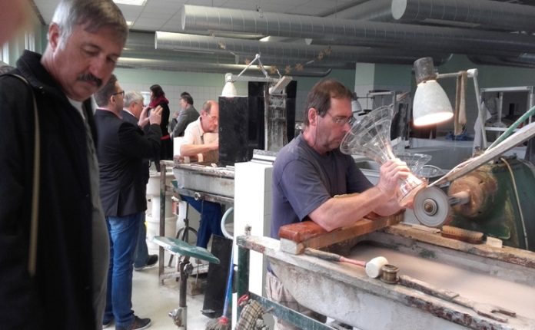 | 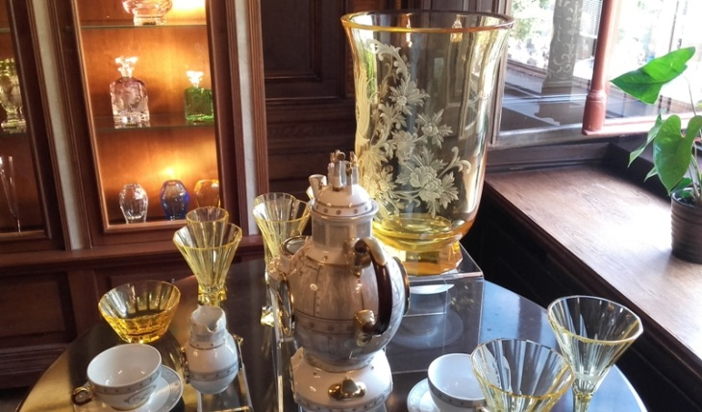
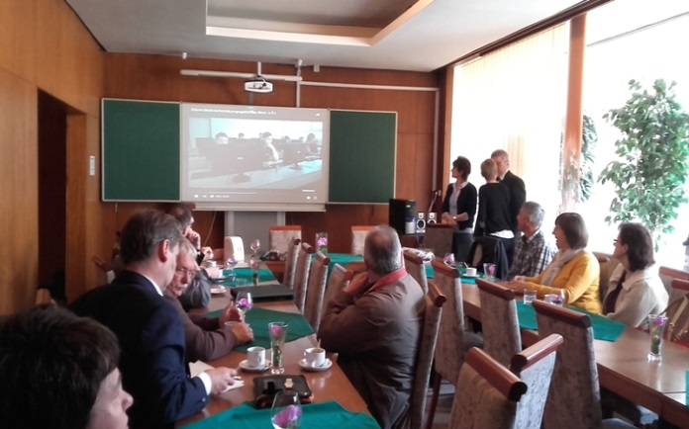 | 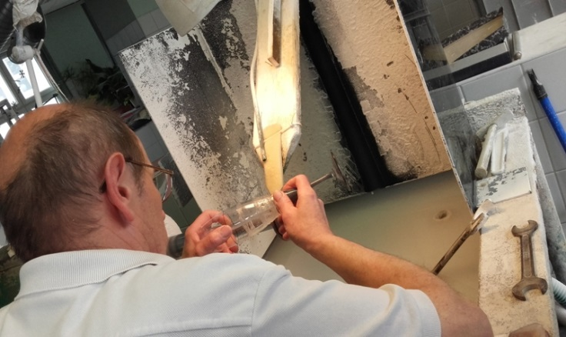
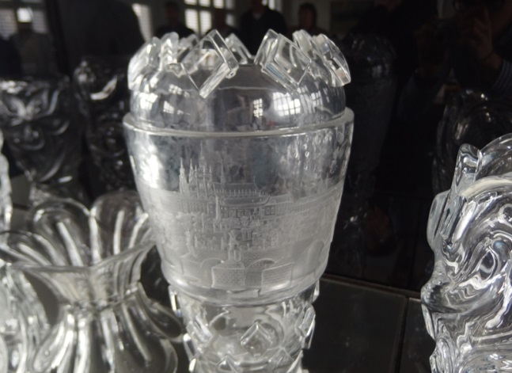 |  | 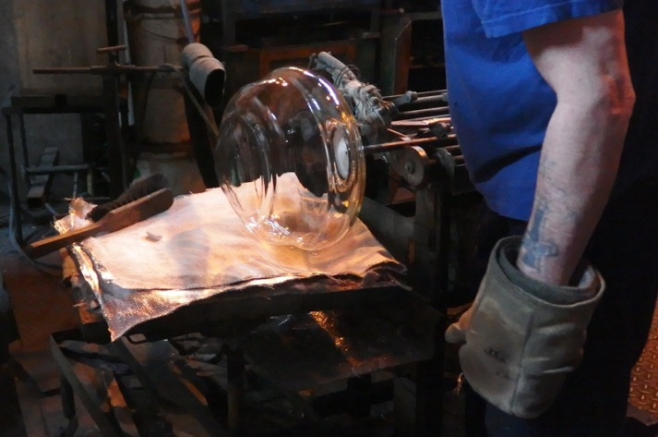
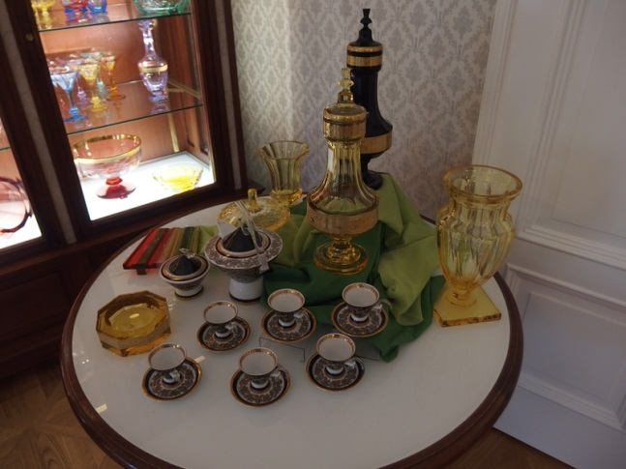 |  | 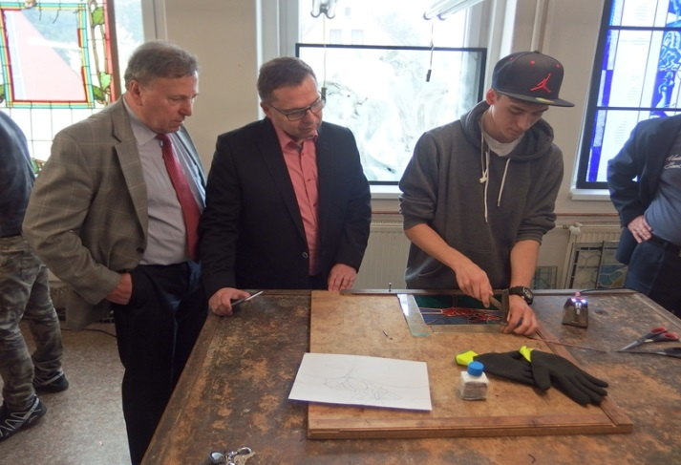

- Construction sector workshop in Poland
The third workshop was carried out in Poland between 19—20 May 2016, organized by the Małopolska Chamber of Craft and Entrepreneurship, (Małopolska Izba Rzemiosła i Przedsiębiorczości) for the construction industry. On the first day, the representatives of professional organizations, entrepreneurs and vocational school experts from the four countries visited a Polish vocational training school, and took part on the practical training of small construction companies. On the second day, more vocational and practical training sites were visited, and a meeting was conducted between the representatives of the professional associations of the four countries. See the program of the workshop and photo documentation of the meetings below.
The Program of the construction sector workshop in Poland
Date: 19—20. May 2016
Venue: Poland: Krakow, Wieliczka

19.05. 2016 (Thursday) –Krakow
07:30 – 08:30 – breakfast, Hotel Kaipol
09:30 – 11:00 – visit + workshop at Rzemieślnicza Zasadnicza Szkoła Zawodowa Małopolskiej Izby Rzemiosła i Przedsiębiorczości w Krakowie (Kraków, ul. Rzeźnicza 4) - It’s a MIRiP school, opened in 2014.
Contact: Elżbieta Kosacka, director,
tel. +48 12 421 38 44; e-mail: el31kok@gmail.com
11:30 – 13:00 – visit Centrum Kształcenia Praktycznego (Kraków, ul. Krupnicza 42)
Contact: Marek Filipczyk, director - Workshops with many professions
tel. +48 12 422 32 18, e-mail: ckpkrakow@interia.pl
13:00 – 13:45 – journey to Wieliczka (20 km from Kraków)
13:45 – 14:45 – lunch in Wieliczka,
15:00 –16:30 – visit + workshop at Zakład Remontowo-Budowlany Roman Koszyk
(Wieliczka, ul. Słowackiego 3/4) - He’s the owner of a small business company
Contact: Roman Koszyk, owner
tel. +48 602 25 03 59, e-mail: roman.koszyk@wp.pl

20.05.2016 (Friday) – Krakow (all transfers by public transport)

08:00 – 09:00 – breakfast, Hotel Kaipol
09:30 – 10:30 – visit Adamski Dachy, Kraków, ul. Wesele 41
- He’s the owner of a small business company, he renovates roofs (he has a large experience in this profession for example St. Mary Church)

Contact: Grzegorz Adamski, owner
tel.: +48 606 135 770 e-mail: adamskidachy@onet.pl
11:00 – 13:00 – Zespół Szkół Budowlanych Nr 1 (Kraków, ul. Jerzego Szablowskiego 1)
- It’s a typical construction school with workshops.
Contact: Andrzej Mielczarek, director
tel.: +48 12 637 1353 e-mail: zsbnr1@poczta.onet.pl
and Centrum Kształcenia Praktycznego, Wydział Budowlany (Kraków,ul. Wesele 41) It’s a typical construction workshop.
Contact: Piotr Pasternak, vice-director
tel.: +48 12 636 74 45 e-mail: ckpkrakow@interia.pl
13:30 – 14:30 – lunch in Krakow,
15:00 – 16:30 – visit ZISTECHNIKA (Kraków, ul. Zygmuntowska 12)
Contact: Korczynski Wladyslaw, owner
tel.: +48 12 638 2020 e-mail: biuro@zistechnika.pl
18:00– 20:00 – dinner at Restaurant Cechowa (Krakow, ul. Jagiellonska 12)
tel. +48 12 421 09 36 www.restauracjacechowa.pl
Common dinner with the Chairman of the Board of ZRP Krakow (Janusz Kowalski) and president of construction sector professional association +informal evaluation of the workshop.

Local organizer: Tomasz Kowalik, Project manager
Malopolska Izba Rzemiosla i Przedsiebiorczosci w Krakowie (Malopolska Chamber of Craft and Entrepreneurship )
św. Anny 9, 31-008 Kraków

Mobil: +48-664-493-278
Telefón: +48-12 422 0595
E-mail:kowalik.mirip@op.pl
Web: http://www.izba.krakow.pl
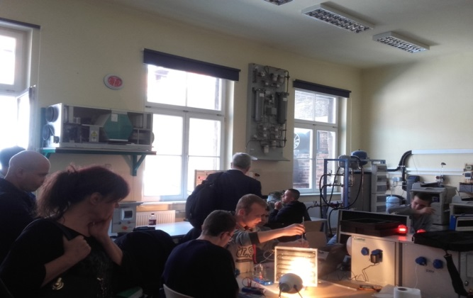 | 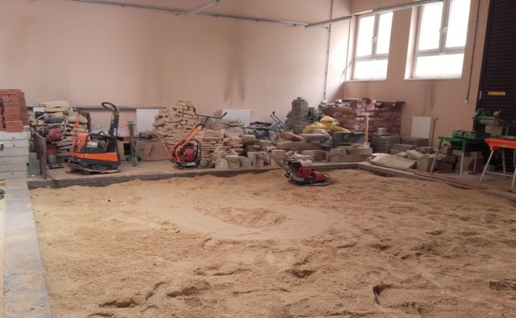
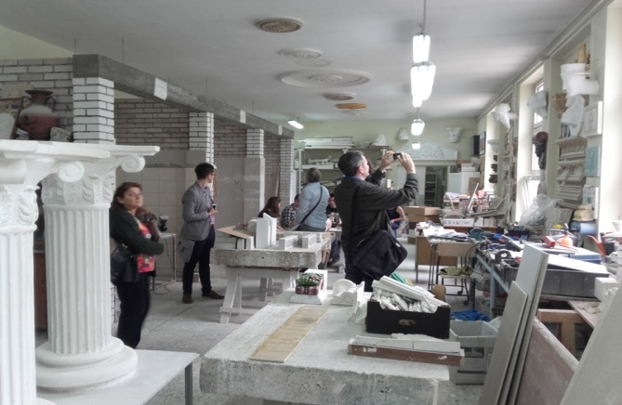 | 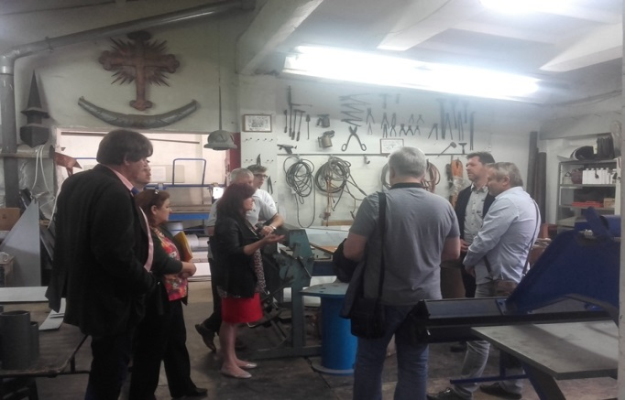
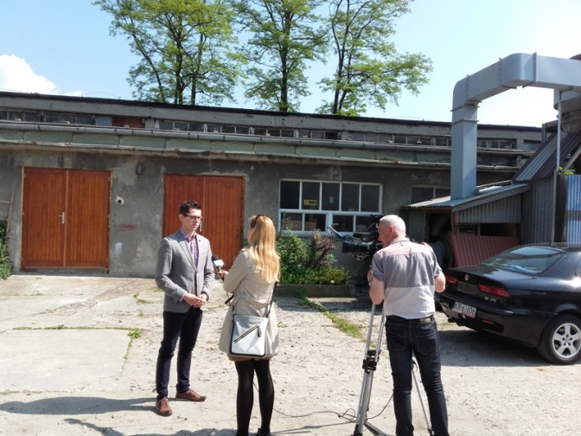 | 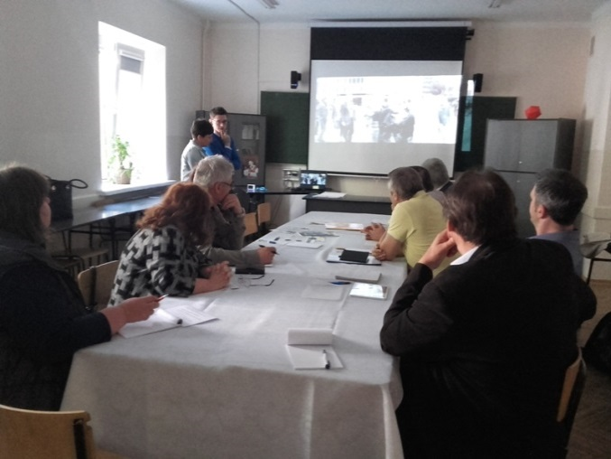
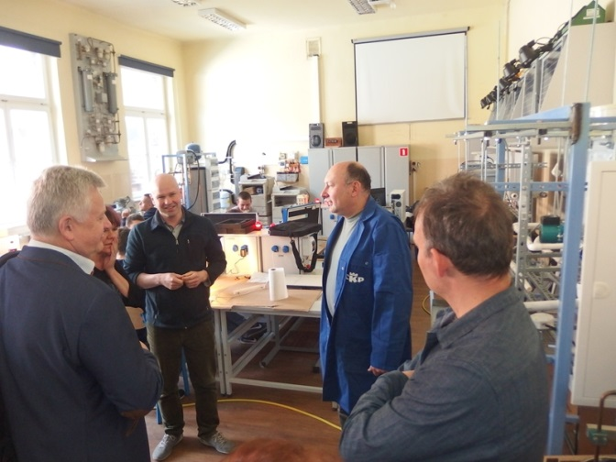 | 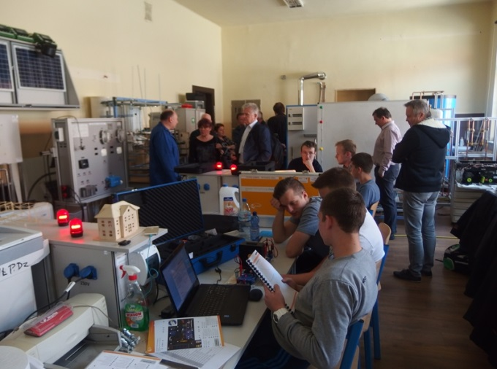
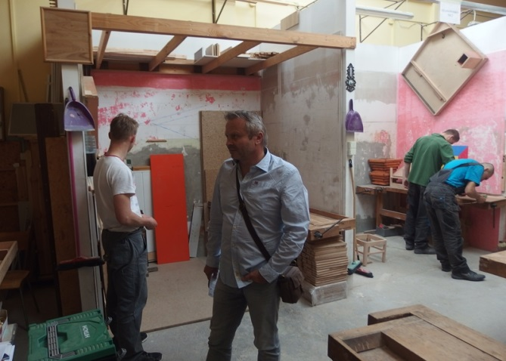 | 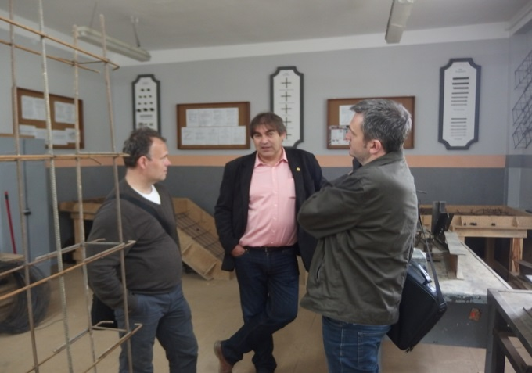
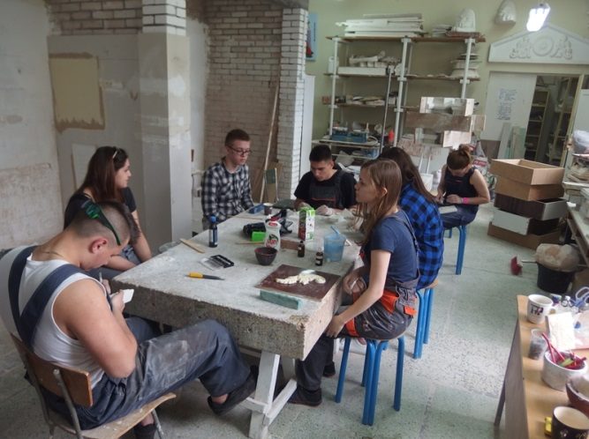 | 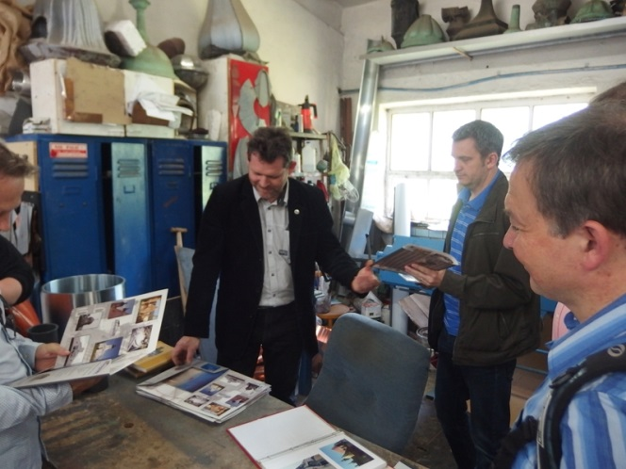
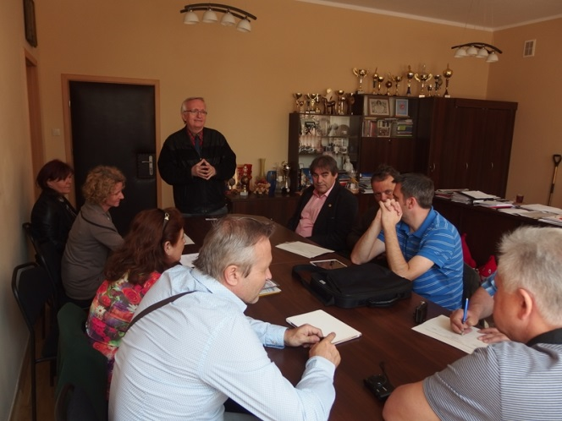 | 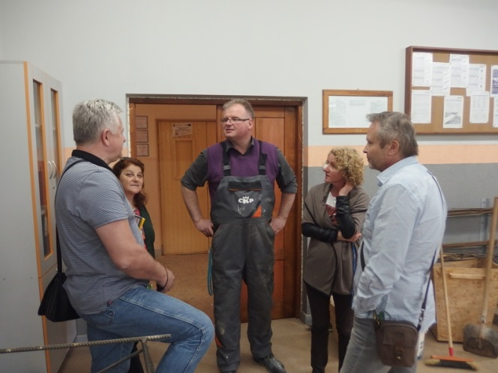

- Metal sector workshop in Hungary
The fourth workshop was carried out in Hungary between 01—02 June 2016, organized by the Hungarian Association of Craftsmen’s Corporations, (Ipartestületek Országos Szövetsége), for the metal industry. On the first day, the representatives of professional organizations, entrepreneurs and vocational school experts from the four countries took part on the practical training of small companies. On the second day, the delegates visited a Hungarian vocational training school and a meeting was conducted between representatives of the professional associations of the four countries. See the program of the workshop and photo documentation of the meetings below.
The Program of the metal sector workshop in Hungary
Date: 01—02. June 2016
Venue: Hungary: Esztergom, Ebszőnybánya

01.06. 2016 (Wednesday) –Esztergom
07:00 – 08:30 – breakfast, Alabárdos Panzió
09:00 – 09:30 journey to Ebszőnybánya (cc. 15 km)
09:30 – 12:00– visit + workshop at Mitter és Társa Kft. Factory (Ebszőnybánya, Vájár Street 2.)
Contact: Mr. Gábor Mitter, owner
Tel: +36 33-500-830
E-mail: mitter.gabor@mitter.hu
12:00 – 12:20 journey to the city of Tát (cca. 10 km from Ebszőnybánya)
12:30 – 13:30 – lunch in Tát,
13:30 – 14:00 – journey to Esztergom (cca. 10 km from Tát),
14:00 –16:30 – visit + workshop at Babits Kft. (2500 Esztergom, Mátyás király Street 37.)
Contact: Mr. Babits Mihály, owner
telephoneNo.: +36 30-916-9172.; e-mail: babitskft@babitskft.hu

02.06.2016 (Thursday) – Esztergom
07:00 – 08:30 – breakfast, Alabárdos Panzió
09:00 – 12:00 – visit + workshop at Géza Fejedelem Vocational Training School
(Esztergom, Budai Nagy Antal Street 24.)
Contact: Pfluger Zoltánné, deputy director,
Tel.: +36 33/ 510 000, e-mail: gf.titkar@gmail.com
12:00 – 12:30 Journey to Dorog (cc. 20 km)
12:30 – 13:30 – lunch in Dorog,
13:30 – 14:00 Journey to Esztergom (cc. 20 km)
14:00 – 16:30 – workshop meeting with the V4 professional organizations (Esztergomi Ipartestület, Simor János Street 17, Esztergom)
18:00– 20:00 – common dinner with the President of IPOSZ (László Németh) and President of Metal Sector Hungarian Professional Association (György Szűcs) +informal evaluation of the workshop

Local organizer: Rettich Tamás, Project manager
Hungarian Association of Craftsmen’s Corporations (IPOSZ)
Budapest
Luther u. 4-6.
1087

Mobil: +36-30-385-6048
E-mail: rettich@iposz.hu
Web: http://www.iposz.hu

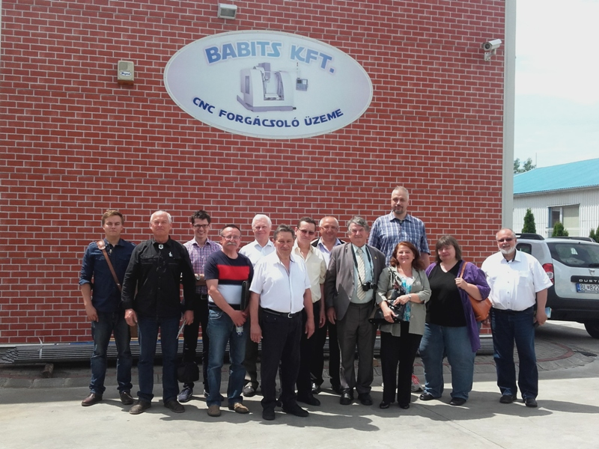 | 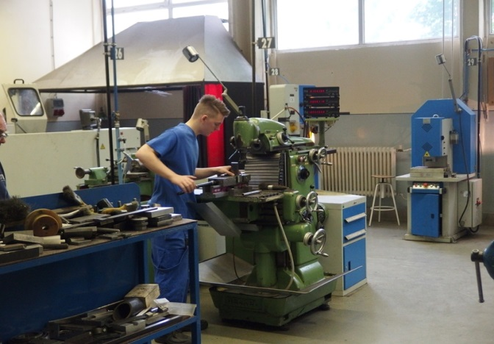
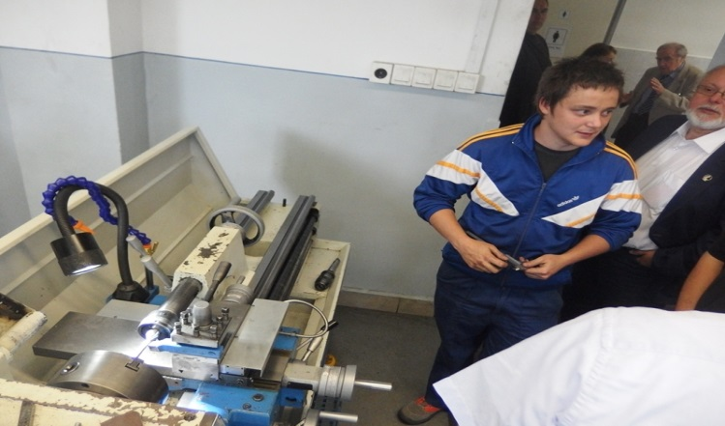 | 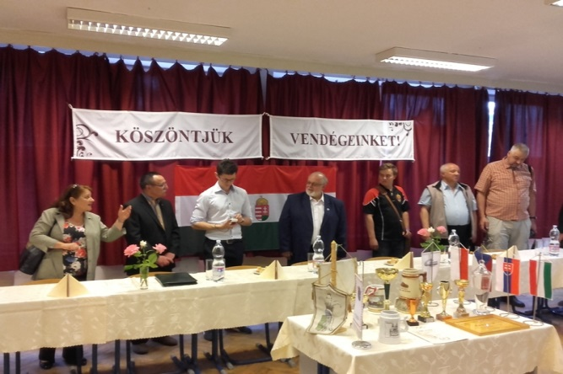
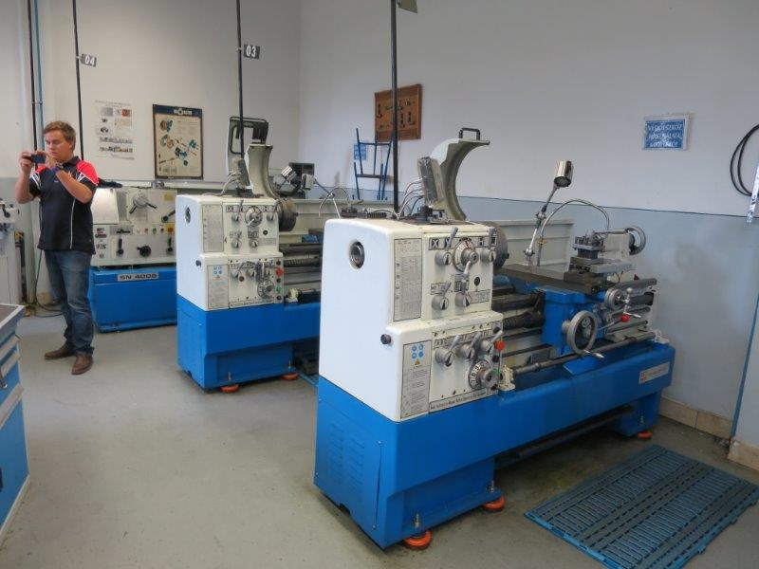 | 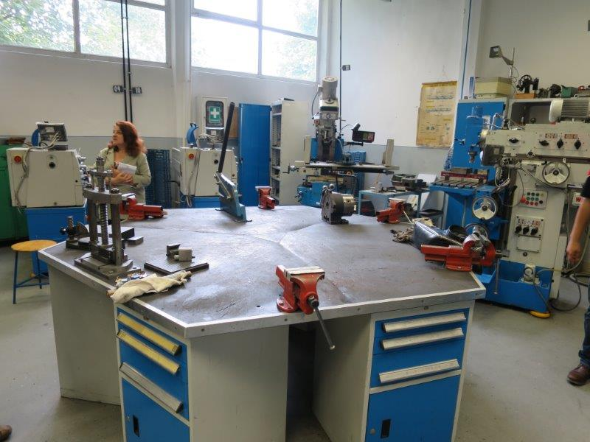
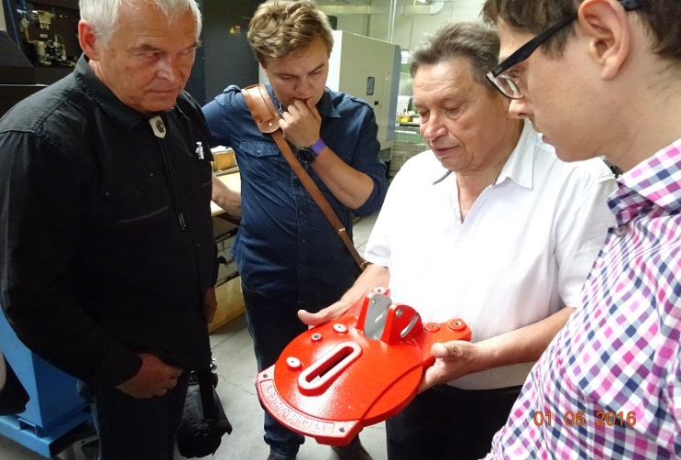 | 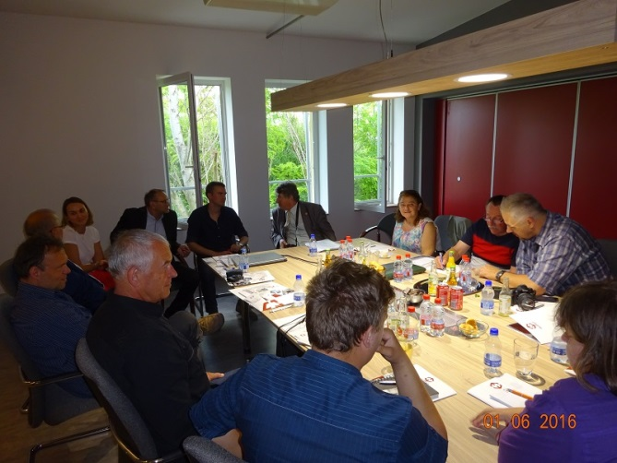
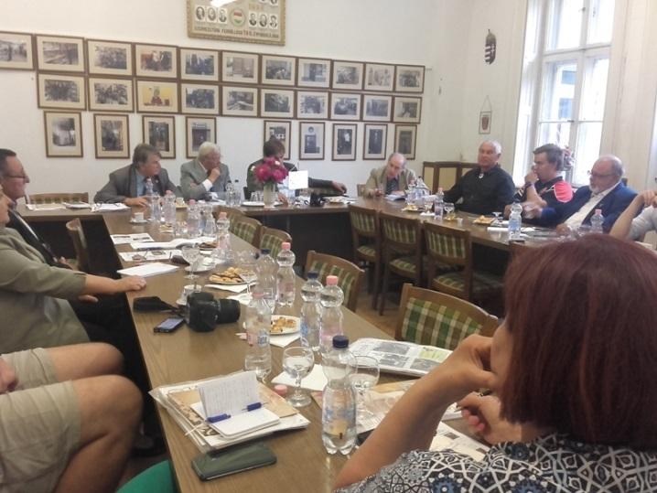 | 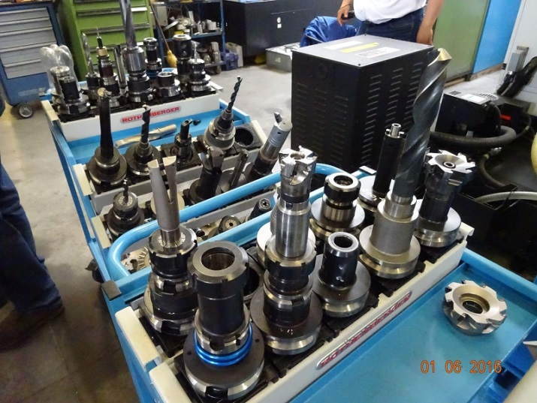
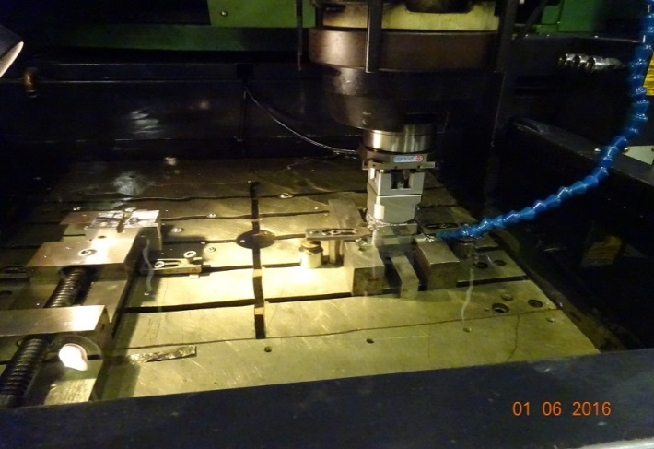 | 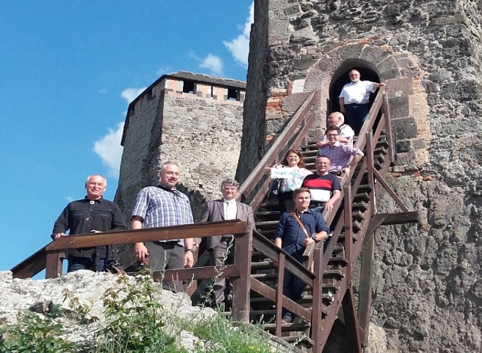

Lists of cc. 5 companies and cc. 2 vocational training schools from every V4 countries, which are interested in keeping contact with companies, vocational training schools from other V4 countries in every profession.

Wood industry – list of companies and schools

The Czech Republic
Companies

Terra Interier  Address:  Štechova 299  500 09 Hradec Králové  Pavel Česák  Tel: +420 605 949 449  E-mail: mail@terra-interier.cz  www.terra-interier.cz | Pjaták  Custom furniture  Address:  Palackého třída 58  612 00 Brno  Tel: +420 775 999 035  E-mail: info@pjataka.cz  David Pjaták, company owner  Tel: +420 776 216 723  E-mail:david@pjatak.cz  www.pjatak.cz
Truhlářství Milan Kubricht  Joinery Milan Kubricht  Address:  Dubno 3  261 01 Dubno  Milan Kubricht  Tel: +420 725 740 746  E-mail: mkubricht@seznam.cz  www.truhlarstvipribram.cz | Řezbářství Gottwald  Wood Carving Gottwald  Address:  Mlžany 50  503 15 Nechanice  Štěpán Gottwald  Tel: +420 608 481 878  E-mail: gottwalds@seznam.cz  www.rezbarstvi-gottwald.cz
Petr Havlíček
Address:
Vítějeves 214
569 06 Vítějeves
Tel: +420 602 280 714
E-mail: info@fa-havlicek.cz
Petr Havlíček, company owner
Tel: +420 602 780 851
E-mail: petr.havlicek@fa-havlicek.cz
www.fa-havlicek.cz

Schools

Střední škola řemeslná Jaroměř  Craftsmanship school Jaroměř  Address:  Studničkova 260  551 01 Jaroměř  Tel: +420 491 812 425  E-mail: sekretariát@sou-jaromer.cz  Mgr. Jitka Kočišová  Principal  Tel: +420 736 784 736  E-mail: kocisova@sou-jaromer.cz  Contact person:  Zdeněk Vítek  Tel: +420 605 472 768  E-mail: kovar.zv@seznam.cz  www.skola-jaromer.odnas.cz | Střední škola řemeslná a Základní škola Soběslav  Craftmanship school Soběslav  Address:  Wilsonova 405  392 01 Soběslav  Tel: +420 389 822 800  E-mail: info@ssrsobeslav.cz  Ing. Darja Bártová  Principal  Tel: +420 389 822 821  E-mail: bartova.darja@ssrsobeslav.cz  Mgr. Alena Háková  Deputy Principal for Technical Fields  Tel: +420 774 415 569  E-mail: hakova.alena@ssrsobeslav.cz  www.ssrsobeslav.cz
Střední odborná škola a Střední odborné učiliště  Vocational School  Address:  Vocelova 1338  500 02 Hradec Králové  Tel: +420 495 212 861  E-mail: sekretariat@sosasou-vocelova.cz  Ing. Vladislav Košťál  Tel: +420 604 202 177  E-mail: kostal@sosasou-vocelova.cz  www.sosasou-vocelova.cz | Akademie – Vyšší odborná škola, Gymnázium a Střední odborná škola umělecko- průmyslová Světlá nad Sázavou  Academy of Arts Světlá nad Sázavou  Address:  Sázavská 547  582 91 Světlá nad Sázavou  Tel: +420 569 452 441  E-mail: skola@akademie-svetla.cz  Ing. Jindřich Vodička  Principal  Tel: +420 569 729 251  E-mail: vodicka@akademie-svetla.cz  Mgr. Zdeněk Loudát  Deputy Principal for Practical Teaching  Tel: +420 774 925 359  E-mail: loudat@akademie-svetla.cz  www.akademie-svetla.cz  www.umprum-svetla.cz
Střední škola umělecká a řemeslná  School of Arts and Crafts  Address:  Nová Zlíchov 1  150 00 Praha 5  Tel: +420 251 115 411  Email: ssuar@ssuar.cz  Mgr. Ing. Jana Porvichová, Ph. D.  Principal  Tel: +420 724 884 143  E-mail: jana.porvichova@ssuar.cz  www.ssuar.cz | Střední škola stavební Jihlava  Engineering school Jihlava  Address:  Žižkova 1939/20  586 01 Jihlava 1  Tel: +420 567 578 560  E-mail: info@ssstavji.cz  PhDr. Pavel Toman  Principal  Tel: +420 567 578 576  E-mail: ptoman@ssstavji.cz  Ing. Josef Štrouf  Deputy Principal for Practical Teaching  Tel: +420 567 570 072  E-mail: jstrouf@ssstavji.cz  www.ssstavji.cz
Střední škola technická Most  Technical school Most  Address:  Dělnická 21  434 01 Most  PaedDr. Karel Vokáč  Principal  Tel: +420 476 137 501  E-mail:vokac.karel@sstmost.cz  Olga Grznárová  Secretary  Tel: +420 476 137 211  E-mail: grznarova.olga@sstmost.cz  www.sstmost.cz | Střední škola polytechnická Brno, Jílová  Polytechnic school Brno, Jílová  Address:  Jílová 164/36g  639 00 Brno  Tel: +420 543 424 511  E-mail: sou@jilova.cz  Ing. Andrzej Bartoś  Principal  Tel: +420 777 995 522  E-mail: bartos@jilova.cz  Contact person:  Ing. Jaroslav Smékal  Tel: +420 723 754 770  E-mail: smekal@jilova.cz  www.jilova.cz
Akademie řemesel Praha - Střední škola technická
Academy of Crafts Prague – Technical School
Address:
Zelený pruh 1430/50
147 08 Praha 4
Tel: +420 244 007 007
E-mail: studium@zelenypruh.cz
Ing. Drahoslav Matonoha
Principal
E-mail: dmatonoha@zelenypruh.cz
Contact person:
Petr Šubrt
Tel: +420 776 752 942
E-mail: subrt@zelenypruh.cz
www.zelenypruh.cz

Hungary
Companies

Árkossy Faipari Kft.  Address:  8440 Herend,  hrsz. 010/25. Pf.: 26  Árkossy Tamás  Company owner  e-mail: arkossytamas@arkossy.hu  Telefon: +36 88/513 630  Fax: +36 88/513 631  e-mail: info@arkossy.hu  honlap: www.arkossy.hu |  | Sárvári Faipari Kft.  Address:  H-8000Székesfehérvár, Városkapu üzletház–8-as főút13. km.  Tel: +36 (22) 507-125  E-mail: sarvariasztalos@datatrans.hu  Sárvári József  Managing director  Tel: + 36 20 594-4787  www.sarvari.hu
Partam Kft.  Address:  1044Budapest,  Megyeri út 8-10.  e-mail:postmaster@partam.t-online.hu  Telefon: +36 1/390-0056 |  | Csercsics Faipari Kft.  Address:  H-9791 Torony, Felsőőri utca - Ipartelep u. 3.  Tel: +36 (94) 540-650  E-mail: csercsics@csercsics.hu  Csercsics Antal  Managing director  Tel: + 36 30 9470-960  www.csercsics.hu
HorváthFaipari Kft.  Address:  6000Kecskemét,  Kaffka Margit u. 3.  Horváth Ildikó  Managing director  email horvath.ildiko@horvathfaipari.hu  Telefon: +36 76/505048  +36 30/370-7900  Fax: +36 76/481558  e-mail: info@horvathfaipari.hu  honlap: http://horvathfaipari.hu/ |  | Szili József soleproprietor  Address:  H-6000Kecskemét, Pipacs utca 6.  Tel: +36 (76) 508-310  E-mail: szilijozsef@szilibutor.hu  Tel: + 36 30 9536-821,  +36 (76) 326-617, +36 70/777-9078  http://butorbolt.hu/adatlap/268,szili-jozsef.html
Schools

Piarista Szakközépiskola, Szakgimnázium és Kollégium  Craftsmanship school Göd  Address:  Jávorka Sándor u. 18.  2131 Göd  Tel: +36 27 345 167  E-mail: god@g-piar.hu  Dekiszkyné Fejér Rita  Director  Contact person:  Pelyhes Gábor  Education Leader for Practical Training  Tel: +36 30 668 8561  E-mail: gabor.pelyhes@gmail.com  http://www.g-piar.hu/ | Kaesz Gyula Faipari Szakközépiskola és Szakiskola  Craftmanship school Budapest  Address:  Egressy út 36.  1149Budapest  Tel: +361 252 1000  E-mail: kaesz@kaeszgy.sulinet.hu  Kellnerné Füzi Mária  Director  Contact person:  Babanecz Csaba  Education Leader for Practical Training  Tel: +36 30 2902390  E-mail: babanecz@gmail.com  http://kaesz.hu/
Hefele Menyhért Építő- és Faipari Szakgimnázium és Szakközépiskola
Craftsmanship school Szombathely
Address:
Szent Márton u. 77.
9700 Szombathely
Tel: +36 94 324 548
E-mail: hefele@hefele.sulinet.hu
Dr. Szalai Péter
Director
Contact person:
Mész János
woodworking engineer
http://www.hefele.sulinet.hu/

Poland
Companies

MEBLO - MARK  Address:  32-420 Gdów 978  Marek Skrzypiec  Company owner  e-mail: meblomark1@gmail.com  Telefon: +48604/29 69 81 |  | Zaklad Stolarski STOLFACH  Address:  ul. Przylesie 41  30-444 Libertów  Józef Majerczyk  Managing director  Tel: +48 602635628  E-mail: majerczyk@stolfach.com.pl  http://stolfach.com.pl/
PPHU "Stelar"  Address:  ul. Centralna 37,  31-982 Kraków  Janusz Wojciechowski  Managing director  Tel: + 48 607 611 859, +48 691 611 859  e-mail: studio@stelar.pl  https://stelar.pl/ |  | Zakład Stolarski Jan Ciszek  Address:  ul. Torowa 3  30-435 Kraków,  Jan Ciszek  Managing director  Tel: +48 504134430  E-mail: stolarniaciszekandciszek@interia.pl
Zakład Stolarski Edward Bartyzel
Address:
ul. Myślenicka 182
30-698 Kraków,
Edward Bartyzel
Managing director
Tel: +48 501031423
E-mail: krystynka537@wp.pl
Schools

Rzemieślnicza Zasadnicza Szkoła Zawodowa Małopolskiej Izby Rzemiosła i Przedsiębiorczości w Krakowie  Address:  ul. Rzeźnicza 4,  31-540 Kraków  www.szkola.izba.krakow.pl  E-mail: szkola@izba.krakow.pl  Tel: +48 12 4138698 | Zespół Szkół Budowlanych w Krakowie  Address:  ul. Jerzego Szablowskiego 1,  30-127 Kraków  Tel: +48 12 637 13 53  www.zsb1.pl  E-mail: mhpolaska@vip.onet.pl
Centrum Kształcenia Praktycznego
ul. Krupnicza 42 a, 31-123 Kraków
tel. 48 12 422 32 18
e-mail: ckpkrakow@interia.pl

The Slovak Republic
Companies

Decodom, spol. s.r.o.  Address:  Pílska 7, 955 13 Topoľčany, Slovakia  Contact:Ing. Roman Gejdoš, Mrs. Margita Rodinová,  Tel.: +421 38/ 53 52485, +421 911 068405  e-mail:osobne@decodom.sk ; http://www.decodom.sk |  | SOFA TREND, s.r.o.  Address:  Tovarnícka 3976, 955 01 Topoľčany, Slovakia  Contact: Roman Merašický,  Tel.: +421385320721, Tel./fax: +421385320722  e-mail:sofatrend@sofatrend.eu, http://www.sofatrend.sk
GKT, s.r.o.  Address:  Pivovarnícka 2824/22, 95501 Topoľčany, Slovakia  Contact:Ing. Gustáv Krchňavý,  Tel.: +421 903 719409  e-mail:krchnavy@gkt.sk; http://www.gkt.sk/ |  | FINIT WOOD, s.r.o.  Address:  956 16 Čeľadince 2, okr. Topoľčany, Slovakia  Contact:Ing. Damian Rybanský,  Tel.: +421 903 243 741, +421 38 536 74 15  e-mail:damian@finit.sk; http://www.finit.sk
Schools / Professional organisations

Stredná odborná škola drevárska (Secondary Wood Vocational School),  Address:  Pílska 7, 955 01 Topoľčany,  Contact: Mgr. Miloš Bobula, school director,  telephon Nr.: +421/38 53 63 211;  e-mail: sekretariat@sosdrevarska.sk | Stredná odborná škola stavebná (Secondary Construction vocational School),  Address:  Nitrianska cesta 61, Nové Zámky;  Contact: Ing. Štefan Száraz, school director  Telephon Nr.: +421/905503142;  e-mail: szaraz@centrum.sk
Sekretariát Zväzu spracovateľov dreva Slovenskej republiky  Contact: PhDr. Peter Zemaník-  general secretary  Address:  T. G. Masaryka 24,  960 53 Zvolen, Slovakia  tel.: + 421 45/5330 278, + 421 45/5206 806, mobil: +421 918 474 987  e-mail:info@zsdsr.sk ; http://www.zsdsr.sk/ | Centrum pre rozvoj drevárskeho, nábytkárskeho a celulózo-papierenského priemyslu  Address:  Dúbravská cesta 14, 841 04 Bratislava  Tel.: +421-911-728611  e-mail:bohacek@vupc.sk; http://www.centrumdp.sk

Glass industry – list of companies and schools

The Czech Republic
COMPANIES – MEMBERS OF THE ASSOCIATION „CZECH ART OF GLASS“

STUDIO RONY PLESL  Address:  Šaldova 1/129  186 00 Praha 8  Czech Republic  doc.ak.soch. Rony Plesl  Tel: +420 606 713 773  E-mal: studio@ronyplesl.com  www.ronyplesl.com | Svaz výrobců skla a bižuterie  Association of the Glass and Jewels manufactures  Address:  Palackého 3145/41  466 01 Jablonec nad Nisou  Czech Republic  Tel: +420 723 640 237  E-mail. info@svsb.cz  JUDr. Pavel Kopáček, Chairman of the Board  Tel: +420 732 174 395  E-mail: info@svsb.cz  www.svsb.cz
Cesty skla, o.p.s.  Ways of Glass  Centrum sklářského umění  Huť František v Sázavě  Address:  Na Kácku 218  285 06 Sázava  Czech Republic  MgA. Martina Kulhavá  Director  Tel: +420 736 521 859  E-mail: kulhava@cestyskla.cz  www.cestyskla.cz | Ing.František Milichovský  Huť Jakub, Tasice  Address:  Stínadla 1063  584 01 Ledeč nad Sázavou  Czech Republic  Tel: +420 737 728 906  E-mail. f.milichovsky@seznam.cz
Karel Sobotka  Address:  Těpeře 64  468 22 Železný Brod  Mobil: +420 606 127 236  E-mail. sobotka.figurky@seznam.cz  www.sklenene-foukane-figurky.cz | Sdružení Za záchranu kostela Sv. Jiljí  Association for the rescue of the St Giles church  Address:  Chýšská 109  439 83 Lubenec  Jitka Kantová  Tel: +420 603 8181 85  E-mail: skloart@skloart.cz
Sklárna Florianova huť  Glasshouse Florianova huť  Address:  Častolovice 16  470 01 Česká lípa  Petr Červený  Director  Mobil: +420 603 894 297  E-mail: info@florianova.hut.com  www.florianovahut.com | J.Art RCA, akad.malíř Jiří Šuhájek  J Art RCA, Academic painter Jiří Šuhánek  Address:  Jeremenkova 89  Praha 4  Tel: +420 602 787 472  E-mail: suhajek@volny.cz  www.jirisuhajek.com
Ateliér Žampach  Address:  Horní Valy 610  688 01 Uherský Brod  Stanislav Žampach  Tel: +420 572 634 071  Mobil: +420 603 287 678  e-mail: info@zampach.com  www.zampach.com | CZEVITRUM s.r.o.  Address:  Československé armády 390/9  150 00 Praha 6  Karel Putnar  Telefon: +420 775 203 812  E-mail: putnar@czevitrum.com
CREATEAM s.r.o.  Address:  Neklanova 11  128 00 Praha 2  Ing.Ladislav Kopecký  jednatel  Tel: +420 602 339 302  e-mail: studio@createam.cz | Jiří Tesař  Address:  Zátiší 758  473 01 Nový Bor  Tel: 731 76 76 75  E-mail: atjesarjiri@seznam.cz
MOSER, a.s.  Handmade luxury crystal.  Address:  Kpt. Jaroše 46/19  360 06 Karlovy Vary  Czech Republic  Tel: +420 353 416 111  E-mail: customerservice@moser-glass.com  Ing. Antonín Vlk  Company director  Member of the Board  Tel: +420 602 414 763  E-mail: vlk@moser-glass.com  Contact person:  Mgr. Jiří Říha  Tel: +420 602 414 764  E-mail: jiri.riha@upcmail.cz  E-mail: riha@moser-glass.com  www.moser-glass.com | RUCKL CRYSTAL, a.s.  Leaded crystal with gilt, hand cutting and sandblasting.  Address:  Lánská 141  267 05 Nižbor  Czech Republic  Tel: +420 311 691 111  E-mail: info@ruckl.cz  Ing. Simona Prokopová  Chairman of the Board  Tel: +420 311 696 111  E-mail: info@ruckl.cz  Ing. Jiří Rückl, Company President  M: +420 605 229 202  E-mail: ruckl@ruckl.cz  www.ruckl.cz
CRYSTAL BOHEMIA, a.s.  Manufacturing items from hand-cut or molded lead crystal.  Address:  Jiráskova 223  290 01 Poděbrady  Czech Republic  Tel: +420 325 602 111  E-mail: company@crystal-bohemia.com  Ing.Jaroslav Seifrt st.  Vice-chairman of the Board  Tel: +420 602 376 350  www.crystal-bohemia.com | PRECIOSA GROUP  Preciosa, a.s.  Address:  Opletalova 3197  466 67 Jablonec nad Nisou  Andrea Kroupová, MBA  M: +420 739 520 086  E-mail: andrea.kroupova@preciosa.com  www.preciosa.com
CAESAR CRYSTAL BOHEMIAE, a.s.  Traditional hand made crystal produced since 1861. Manufacture by hand cut lead crystal with gilt painted glass decor.  Address:  Josefodol 2  582 91 Světlá nad Sázavou  Tel: +420 569 469 320  E-mail: caesar@caesar-crystal.cz  Contact person:  Ing. Dušan Chatrný  CEO  Chairman of the Board  M: +420 606 76 74 76  E-mail: chatrny@caesar-crystal.cz  www.caesar-crystal.cz | EGERMANN, s.r.o.  Decorative, utility and highly art-oriented painted glass products.  Address:  Dvořákova 306  473 01 Nový Bor  Czech Republic  Tel: +420 487 722 000  E-mail: office@egermann.cz  Ing. Robet Uksa  Managing Director  Tel: +420 487 722 471  E-mail: office@egermann.cz  www.egermann.cz
SKLÁRNA SLÁVIA, s.r.o.  Hand made decorated glass,high enamel, painted glass and metallurgical products.  Address:  Sluneční 892  473 01 Nový Bor  Tel: +420 777 747 121  E-mail: slavia@sklarna-slavia.cz  Ing. Martin Pečený  Director  Tel: 774 0044 88  E- mail: peceny.martin@sklalrna-slavia.cz  www.sklarna-slavia.cz | BOHEMIA MACHINE, a.s  Utility drinking glass manufacture designed by prominent Czech and foreign artists.  Address:  Zámecká 1127  582 91 Světlá nad Sázavou  Czech Republic  Tel: +420 569 453 149  E-mail: info@bomma,cz  Contact person: Luboš Kadlec  Sales Manager  Mobil: +420 730 15 11 85  E-mail: l.kadlec@bohemia-macine.cz  www.bohemia-machine.cz
GRANÁT TURNOV, družstvo umělecké výroby  The biggest producer of original jewelries with the bohemian garnets.  Address:  Výšinka 1409  511 14 Turnov  Czech Republic  Tel: +420 357 216  E-mail: sales@granat.cz  Contact person:  Ing. V. Musil  Business Manager  Tel: +420 481 357 217  E-mail: sales@granat.cz  www.granat.eu | BLAŽEK GLASS  Traditional manufacturer of the glass items, original glass files, decorated glass, crystal urns, trophies and glass jewelry.  Address:  Olbrachtova 600/3  260 01 Poděbrady II  Czech Republic  Tel: +420 325 603 200  E-mail: secretary@blazek-glass.cz  Ing. Lenka Zdobinská, secretary  Tel: +420 325 603 204  Tel: +420 602 746 679  E-mail: jzdobinsky@blazek-glass.cz  E-mail. lzdobinska@blazek-glass.cz  www.blazek-glass.cz
Richard Kanta - SKLO  Address:  Chýšská 158  439 83 Lubenec  Ing. Richard Kanta, company owner  Tel: +420 603 81 81 85  E-mail: skloart@skloart.cz | Petr Larva, Mgr.A  Address:  Plavecká 9  120 00 Praha 2  Tel: +420 725 804 904  E-mail: petr.larva@seznam.cz
Schools

Vyšší odborná škola sklářská a Střední škola Nový Bor  Glass school Nový Bor  Address:  Wolkerova 316  473 01 Nový Bor  Czech Republic  PaedDr. Irena Jindrová  Principal  Tel: +420 487 712 211  Pavel Tille  M: +420 728 983 283  Tel: +420 487 833 320  E-mail: tille@glassschool.cz  E-mail: info@glassschool.cz  www.glassschool.cz | Střední uměleckoprůmyslová škola sklářská Železný Brod  Glass school of Art Železný Brod  Address:  Smetanovo zátiší 470  468 22 Železný Brod  Czech Republic  Tel: +420 483 346 162  E-mail: sekretariat@supss.cz  MgA. Libbor Doležal  Principal  Tel: +420 483 346 162  E-mail: libor.dolezal@supss.cz  MgA. Martin Hlubuček  Deputy principal  E-mail: hlubucek@supss.cz  www.supss.cz
Střední průmyslová škola keramická a sklářská Karlovy Vary  Glass and Ceramics technical school Karlovy Vary  Address:  Nám. 17. listopadu 12  360 05 Karlovy Vary  Czech Republic  Tel: +420 353 563 875  E-mail: sekretariát@spskkv.cz  Ing. Markéta Šlechtová  Principal  Tel: 739 322 443  Ing. Libuše Ladýřová, Deputy Principal  M: +420 776 030 097  E-mail: libuse.ladyrova@spskkv.cz  www.spskkv.cz | Střední uměleckoprůmyslová sklářská škola Valašské Meziříčí  Glass school of Art Valašské Meziříčí  Address:  Zašovská 100  757 01 Valašské Meziříčí  Czech Republic  Tel: +420 571 621 466  E-mail: kancelář@sklarskaskola.cz  Mgr. Dana Budayová  Principal  Tel: +420 571 621 466  www.sklarskaskola.cz  Contact person:  Ing. Radim Roška, Deputy principal  Tel: +420 731 581 938  E-mail: rroska@sklarskaskola.cz
Uměleckoprůmyslová akademie Světlá nad Sázavou  Academy of Art Světlá nad Sázavou  Address:  Sázavská 547  582 91 Světlá nad Sázavou  Czech Republic  Tel: +420 569 452 441  E-mail: škola@akademie-svetla.cz  Ing. Jindřich Vodička  Principal  Tel: +420 569 729 253  E-mail: vodicka@akademie-svetla.cz  MgA. Milan Krajíček  Chief Artist  E-mail: krajicek@akademie-svetla.cz  mobil: 777158935  www.akademie-svetla.cz | Střední uměleckoprůmyslová škola Kamenický Šenov  School of Art Kamenický Šenov  Address:  Havlíčkova 57  471 14 Kamenický Šenov  Doc.Mgr.A.Pavel Kopřiva  Principal  M: +420 739 633700  E- mail: kopriva.pavel@gmail.com  www.czech-glass-school.cz  E-mail: supss@supss-ks.cz  tel:+420 487 764 965

Hungary
Companies

Csóli Csaba, sole proprietor  poise@t-online.hu  Telefon: +36 20/953 6657 |  | Bódis Kristály Kft.  Address:  Árpád u. 14/a.  8400 Ajka  Bódis Csaba  Managing director  Tel: +3630/2682559  Tel: +36 88/201-721  E-mail: bodiskristaly@invitel.hu  http://www.bodiskristaly.hu/
Gabi Kristály Kft.  Address:  Cecília u. 4.  2030 Érd  Cserháti Gabriella  Managing director  Tel: +36 20/3265654  E-mail: gabi@olomkristaly.com  http://www.olomkristaly.com/ |  | Kőszegi Kristály Kft.  Address:  Üllői út 40.  1082 Budapest  Kőszegi Levente  Managing director  Tel: +36 20/3516901  +36 1 313-8376
Rákosy Glass Kft.
Address:
Noszlopy u. 3-5.
1103 Budapest
Tel: +36 1 261-0445
E-mail: info@rakosyuveg.hu
http://rakosyuveg.hu/
Schools

KISKÉPZŐ, Képző és Iparművészeti Szakgimnázium és Kollégium
Secondary School of Visual Arts, Budapest
Address:
Török Pál u. 1.
1093 Budapest
Szűcs Tibor
Director
Tel: +36+1/217-6833
E-mail: info@kiskepzo.hu
Contact person:
Kátai Miklós
Tel: +36 30/966-8288
E-mail: katai.miklos@gmail.com
http://www.kiskepzo.hu/index.html

Poland
Companies

Firma KRYSZTAŁ  Address:  33-386 Podegrodzie 210  Tel/Fax. +48 18/ 445-95-04  e-mail: krysztal@krysztal.pl  http://www.krysztal.pl/ |  | Pracownie Witrazy  30-518 Kraków, Rynek Podgórski 13  dr Paczka Krzysztof  Cwilewicz Andrzej  Tel: +48 12 296-17-53  E-mail: biuro@prawit.pl  http://www.prawit.pl/
mgr inż. Freyer Andrzej  30-216 Kraków, ul. Pod Sikornikiem 17  Tel: +48 12 425-18-89  E-mail: frey@poczta.onet.pl |  | Ryszard Łoboda  30-002 Kraków, Prądnicka 5  tel. +48 609 579 185  E-mail: ryszard@witraze-loboda.pl  http://www.witraze-loboda.pl/
Prof. Roman Łaciak  ASP w Krakowie  Tel: +48 12 299 20 31 |  | Gołębiewska Jadwiga  Marcyporęba 394, 34-114 Marcyporęba  jadwiga.golebiewska@gmail.com
Schools

Akademia Górniczo Hutnicza im. Stanisława Staszica w Krakowie
Wydział Inżynierii Materiałowej i Ceramiki
Katedra Technologii Szkła i Powłok Amorficznych
Wydział Inżynierii Materiałowej i Ceramiki AGH
Address: al. Mickiewicza 30, 30-059 Kraków
Tel: +48 12 617 34 19
E-mail: szklo@agh.edu.pl

The Slovak Republic
Companies

Rona a.s., Lednické Rovné
Contact: Ing. Pavol Brnka, Schreiberova 365, 020 61 Lednické Rovne
Tel: 042 469 3613; e-mail: brnka@rona.sk

Schools / Professional organisations

Zväz sklárskeho priemyslu Slovenskej republiky (ZvSP)  Contact: Ing. Štefan Škultéty, PhD., Bratislavská 9, 911 05 Trenčín  Tel: +421 32 652 1285;+421 903 720 675 Fax: +421 32 658 2765,  e-mail: zvsp@zvsp.sk; skultety@zvsp.sk | Slovenský živnostenský zväz– Slovak Craft Industry Federation  Contact: Ing. Viola Kromerová, Račianská 71, 831 02 Bratislava 3  Tel.: +421-2-49 24 62 34, +421-911-249 157, Fax: +421-2-49 24 66 53  sekretariat@szz.sk; kromerova@szz.sk; http://www.szz.sk

Construction industry – list of companies and schools

The Czech Republic
Companies

GibsCon s.r.o.  Adress:  Tyršova 258  664 42 Brno Modřice  Contact person:  Květoslav Škrob  Business Manager  Tel: +420 777 582 189  E-mail: gioscon@gipscon.cz  www.gipscon.cz | Archeus s.r.o.  Address:  V. Volfa 1336/35  370 05 České Budějovice  Ing.arch. Zdeněk Kadlec  Managing Director  Tel: +420 774 456 801  E-mail: kadlec@archeus.eu  www.archeus.eu
Stavba Bartoš  Construction Bartoš  Address:  Dolany 84  273 51 Unhošť  Tel: +420 312 662 436  E-mail: gabina@stavbabartos.cz  Luděk Bartoš  Managing Director  Tel: +420 777 232 499  E-mail: ludek@stavbabartos.cz  www.stavbabartos.cz | Bergmann stavby  Bergman constructions  Address:  Krátká 13  284 01 Kutná Hora  Jakub Hubáček  Constuction Supervisor  Tel: +420 608 605 615  E-mail: hubacek@bergmann-stavby.cz  www.bergmann-stavby.cz
DOMAR stavby s.r.o.
DOMAR constructions
Address:
Sadová 177
Nemošice
530 03 Padubice
E-mail: info@domarstavby.cz
Tel: +420 776 370 314
www.domarstavby.cz

Schools / Professional organizations

Střední odborná škola a Střední odborné učiliště  Vocational School  Address:  Vocelova 1338  500 02 Hradec Králové  Tel: +420 495 212 861  E-mail: sekretariat@sosasou-vocelova.cz  Ing. Vladislav Košťál  Tel: +420 604 202 177  E-mail: kostal@sosasou-vocelova.cz  www.sosasou-vocelova.cz | Střední škola stavební Jihlava  Engineering school Jihlava  Address:  Žižkova 1939/20  586 01 Jihlava 1  Tel: +420 567 578 560  E-mail: info@ssstavji.cz  PhDr. Pavel Toman  Principal  Tel: +420 567 578 576  E-mail: ptoman@ssstavji.cz  Ing. Josef Štrouf  Deputy Principal for Practical Teaching  Tel: +420 567 570 072  E-mail: jstrouf@ssstavji.cz  www.ssstavji.cz
Střední škola technická Most  Technical school Most  Address:  Dělnická 21  434 01 Most  PaedDr. Karel Vokáč  Principal  Tel: +420 476 137 501  E-mail:vokac.karel@sstmost.cz  Olga Grznárová  Secretary  Tel: +420 476 137 211  E-mail: grznarova.olga@sstmost.cz  www.sstmost.cz | Střední škola polytechnická Brno, Jílová  Polytechnic School Brno, Jílová  Address:  Jílová 164/36g  639 00 Brno  Tel: +420 543 424 511  E-mail: sou@jilova.cz  Ing. Andrzej Bartoś  Principal  Tel: +420 777 995 522  E-mail: bartos@jilova.cz  Contact person:  Ing. Jaroslav Smékal  Tel: +420 723 754 770  E-mail: smekal@jilova.cz  www.jilova.cz
Akademie řemesel Praha - Střední škola technická
Academy of Crafts Prague – Technical School
Address:
Zelený pruh 1430/50
147 08 Praha 4
Tel: +420 244 007 007
E-mail: studium@zelenypruh.cz
Ing. Drahoslav Matonoha
Principal
E-mail: dmatonoha@zelenypruh.cz
Contact person:
Petr Šubrt
Tel: +420 776 752 942
E-mail: subrt@zelenypruh.cz
www.zelenypruh.cz

Hungary
Companies / Professional organizations

Németh és Tsa.  Adress:  Erkel F. u. 8.  8400 Ajka  Contact person:  Németh László  Business Manager  Tel: +36 88 202 144  Mobil: +36 20 9246 981  E-mail: nemethestsa@ajkanet.hu | Építőmesterek Szakmai Egyesülete  Address:  Szabadság tér 7.  9090 Pannonhalma,  Elnök: Papp László  Tel: +36 20 9215 864  Tel.: +36 96/470-642  Fax: +36 96/470-642  E-mail: epitomester.szovetseg@gmail.com  Honlap: http://www.epito-mester.hu/
Szobafestő-Mázoló-Tapétázó Országos Ipartestület  1077 Budapest, Wesselényi u. 73.  Elnök: Tóth Antal  Tel: +36 30 466 1390  Tel.:+36 1 950-4682  E-mail: szmtoi@szmtoi.hu ; szmtoi1@gmail.com  Honlap: www.festnet.hu | Cukép Kft.  Address:  Árpád u. 105.  2424 Előszállás  Horváth József  Managing director  Tel: +36 30 9163 986  E-mail: info@cukep.hu  http://www.cukep.hu/
Schools

Faller Jenő Szakképzőiskola és Kollégium  Address:  Szent István út 1.  8100 Várpalota  Tel: +36 88/ 582 520  E-mail: info@falleriskola.hu  Contact:  Mr. István Hajdú, Deputy Director  Tel: +36 30-9291712  E-mail: hajduis@gmail.com  http://falleriskola.hu/ | Dunaújvárosi SZC Hild József Szakgimnáziuma, Szakközépiskolája és Szakiskolája  Address:  Bercsényi u. 8.  2400 Dunaújváros  Tel: +36 25 400 530  E-mail: hild@hild-dunaujv.sulinet.hu  Honlap: http://hildiskola.hu/hild/

Poland
Companies

Firma Budowlano Remontowa Lasoń-Bud  Address:  Szarów 115  32-014 Brzezie,  Tel: +48 12/284 2503  E-mail: biuro@lason-bud.pl  http://www.lason-bud.pl/ | Zakład Remontowo Budowlany,  32-020 Wieliczka, ul. Za Torem 23 a  +48 602 250 359  Roman Koszyk
Zakład Blacharsko – Dekarski Grzegorz Andrzej Adamski  30-127 Kraków, ul. Wesele 41  Email: adamskidachy@onet.pl  Tel: +48 012 637 35 19,  +48 606 135 770  http://www.adamskidachy.krakow.pl/ | Zakład Instalacji Sanitarnych, Jacek Rodacki  30 001 Kraków,ul. Racławicka 50,  Tel: +48 609 111 838  +48 12 633 3788  E-mail: jrodacki1@wp.pl
Zakład Instalacji Sanitarnych, Bogdan Waga  30-009 Kraków, ul. Friedleina 34  bogdan.waga@vp.pl  Tel: +48 12/ 294 5707 | Fhu Marcin Jakubas  32-090 Słomniki, Wężerów 13  Tel: +48 600 384 290  E-mail: marcin.jakubas@interia.pl
Schools

Rzemieślnicza Zasadnicza Szkoła Zawodowa  Małopolskiej Izby Rzemiosła i Przedsiębiorczości w Krakowie  ul. Rzeźnicza 4, 31-540 Kraków  www.szkola.izba.krakow.pl  szkola@izba.krakow.pl  +48 12 4138698 | Zespół Szkół Zawodowych Nr 1  ul. Rzeźnicza 4, 31-540 Kraków  +48 12-421-38-44  e-mail: sekretariat@zsz1.krakow.pl  http://www.zsz1.krakow.pl/
Zespół Szkół Budowlanych w Krakowie  ul. Jerzego Szablowskiego 1, 30-127 Kraków  +48 12 637 13 53  www.zsb1.pl  mhpolaska@vip.onet.pl | Centrum Kształcenia Praktycznego  ul. Krupnicza 42 a, 31-123 Kraków  tel. 48 12 422 32 18  e-mail: ckpkrakow@interia.pl  http://ckp.krakow.pl/

The Slovak Republic
Companies

Jaroslav Kvaššay spol. s r.o.;  Contact: Kvaššay Jaroslav, Továrenská 5144, 901 01 Malacky  Tel.: +421 34/774 1157, Fax:+421 34/774 1158, +421 905/648 684  kvassay@zoznam.sk; stavebniny.kvassay@gmail.com; www.kvassay.sk |  | STRECHY DOBRÍK, s.r.o.  Contact: Dobrík Ľubomír, Stupy 1467/23, 034 48 Liptovské Sliače  Tel.: +421 905/469 456  d.o.p@stonline.sk; www.tesarstvodobrik.sk
ALITREX, s.r.o.  Contact: Dávid Tibor, Ing., Bojnická 24, 831 04 Bratislava 3  Tel.: 0905/753 883  tibor.david@alitrex.sk;www.alitrex.sk |  | DACHCOM, s.r.o.  Contact:Dovičák Ján, Hviezdoslavova 1328, 091 01 Stropkov  Tel.: +421 54/718 1680, Fax: +421 54/718 1681-2, +421 903/910 331  dovicakjan@stonline.sk; www.dachcom.sk
R.J.R.,s.r.o.
Contact:Regec Vladimír, Ing., Stakčínska 141, 069 01 Snina
Tel: +421 57/768 2337, Fax: +421 57/768 2237, +421 905/323 235
vlregec@centrum.sk; www.rjr.sk

Schools / Professional organizations

Cech strechárov Slovenska – Roofers Guild in Slovakia  Contact: Ing. Jana Hodúrová, Zátišie 21, 831 03 Bratislava  Tel.: 0911/538 610; hodurovaj@azet.sk | Slovenský živnostenský zväz– Slovak Craft Industry Federation  Contact: Ing. Viola Kromerová, Račianská 71, 831 02 Bratislava 3  Tel.: +421-2-49 24 62 34, +421-911-249 157, Fax: +421-2-49 24 66 53  sekretariat@szz.sk; kromerova@szz.sk; http://www.szz.sk
Cech podlahárov Slovenska – Floorers Guild in Slovakia  Contakt: Ing. Tibor Pásztor, Štefánikova 118, 949 01 Nitra  Tel. +421 37 656 3211; +421 903434550; pasztor@szz.sk | Cech maliarov Slovenska – Painters´ Guild in Slovakia  Contact: Ing. Angelika Kulmon,Komenského 34, 942 01 Šurany  Tel. +421 905 238 564; +421 907502883; info@cechmaliarov.sk; cechmajster@cechmaliarov.sk; www.cechmaliarov.sk

Metal industry – list of companies and schools

The Czech Republic
Companies

Kovářství Diviš  Blacksmithing Diviš  Adress:  Bříza 62  503 12 Všestary  Radek Diviš  Tel: +420 774 228 001  E-mail: info@kovarstvi-divis.cz  www.kovarstvi-divis.cz | Metal design  Address:  Dolní Třebotín 1  382 01 Dolní Třebotín  Jan Odvárka  Tel: +420 603 570 079  E-mail: jan.odvarka@metal-design.cz  www.metal-design.cz
Kovovýroba Vary  Metalworking Vary  Address:  Kamenec 16  363 01 Stráž nad Ohří  Tomáš Jeřábek  Tel: +420 606 334 957  info@kovovyroba-vary.cz  www.kovovyroba-vary.cz | Umělecké kovářství a zámečnictví Šťastný  Artistic lacksmithing and LocksmithingŠťastný  Address:  Havraní 27,  618 00 Brno  Tomáš Šťastný  Tel: +420 731 466 705  E-mail: info@kovarstvi-stastny.cz  www.kovarstvi-stastny.cz
Čertova kovárna
Address:
Podolí 5
686 04, p. Kunovice
Vítezslav Bobčík
Tel: +420 775 055 283
E-mail: v.bobcik@certovakovarna.cz
www.certovakovarna.cz
Schools

Střední škola řemeslná Jaroměř  Craftsmanship school Jaroměř  Address:  Studničkova 260  551 01 Jaroměř  Tel: +420 491 812 425  E-mail: sekretariát@sou-jaromer.cz  Mgr. Jitka Kočišová  Principal  Tel: +420 736 784 736  E-mail: kocisova@sou-jaromer.cz  Contact person:  Zdeněk Vítek  Tel: +420 605 472 768  E-mail: kovar.zv@seznam.cz  www.skola-jaromer.odnas.cz | Střední škola řemeslná a Základní škola Soběslav  Craftmanship school Soběslav  Address:  Wilsonova 405  392 01 Soběslav  Tel: +420 389 822 800  E-mail: info@ssrsobeslav.cz  Ing. Darja Bártová  Principal  Tel: +420 389 822 821  E-mail: bartova.darja@ssrsobeslav.cz  Mgr. Alena Háková  Deputy Principal for Technical Fields  Tel: +420 774 415 569  E-mail: hakova.alena@ssrsobeslav.cz  www.ssrsobeslav.cz
Střední škola gastronomie a Farmářství Jeseník  School of Gastronomy and Farming Jeseník  Address:  Tel: +420 584 41 171  E-mail: info@sosjesenik.cz  PhDr. Silvie Pernicová  Principal  Tel: +420 734 470 747  E-mail: pernicova@sosjesenik.cz  Ing. Renata Christmannová  Deputy principal for technical and economical section  Tel: +420 739 968 901  E-mail: christmannova@sosjesenik.cz  www.sosjesenik.cz | Akademie – Vyšší odborná škola, Gymnázium a Střední odborná škola umělecko- průmyslová Světlá nad Sázavou  Academy of Arts Světlá nad Sázavou  Address:  Sázavská 547  582 91 Světlá nad Sázavou  Tel: +420 569 452 441  E-mail: skola@akademie-svetla.cz  Ing. Jindřich Vodička  Principal  Tel: +420 569 729 251  E-mail: vodicka@akademie-svetla.cz  Mgr. Zdeněk Loudát  Deputy Principal for Practical Teaching  Tel: +420 774 925 359  E-mail: loudat@akademie-svetla.cz  www.akademie-svetla.cz  www.umprum-svetla.cz
Střední škola umělecká a řemeslná
School of Arts and Crafts
Address:
Nová Zlíchov 1
150 00 Praha 5
Tel: +420 251 115 411
Email: ssuar@ssuar.cz
Mgr. Ing. Jana Porvichová, Ph. D.
Principal
Tel: +420 724 884 143
E-mail: jana.porvichova@ssuar.cz
www.ssuar.cz

Hungary
Companies

Ferzol KFT  Address:  2769 Tápiószőlős, Ceglédi út 15.  Bíró Zoltán managing director  Tel: 06-30-338-7075  E-mail: ferenc.boda@ferzol.hu;ferzol@t-online.hu  http://www.ferzol.hu/ | Borsodi Műhely KFT  Address:  9027. Győr, Juharfa u. 8.  Borsodi László managing director  Tel: 06-20-942-2175  E-mail: info@borsodimuhely.hu  http://www.borsodimuhely.hu/
Weldminker KFT  Address:  8100 Várpalota, Péti út 73/b  Galambos József managing director  Tel: 06-20-922-0752; 06-30-646-8498; 06-22-300-996  E-mail: engima65@gmail.com; weldproduct@t-online.hu  http://weldminker.hu/ | Skribek Pál EV.  2220 Vecsés, Toldy F. u. 65.  Skribek Pál sole proprietor  Tel: 06-30/934-0138  E-mail: skribek@tisztesipar.hu
Vad Sándor  6800 Hódmezővásárhely, Bálint u, 14/a  Vad Sándor sole proprietor  Tel:06-30-233-8118  E-mail: vad.sandor@invitel.hu | VÉMŰ KFT  1107 Budapest, Barabás u. 4.  Végh László managing director  Tel: 06-30-547-3206  E-mail: vemu@t-online.hu  http://www.vemu.hu/hu/cegunkrol.html
Babits KFT
2500 Esztergom, Mátyás Király u. 37.
Babits Mihály managing director
Tel: 06-30-916-9172; 06-33-417-411
E-mail: babitskft@babitskft.hu
Honlap: www.babitskft.hu
Schools

Tatabányai Szakképzési Centrum Géza Fejedelem Ipari Szakgimnáziuma és Szakközépiskolája  Address:  Budai Nagy Antal u. 24.  2500 Esztergom  Kovács Tamás director  Tel: +36 70/400 6913  Tel: +36 33/510 000  +36 20 3064 005  E-mail: gf.titkar@gmail.com  http://gf.sulinet.hu/ | Tatabányai Szakképzési Centrum  Kultsár István Szakgimnáziuma és Szakközépiskolája  Address:  Klapka György út 56.  2900 Komárom  Sípos Sándorné director  Tel: +36 34 3423 75  E-mail: kultsartitkar@freemail.hu  http://www.amckn.sk/kultsaristvan/

Poland
Companies

inż.Słowik Stanisław  31-521 Kraków, ul. Rakowicka 65  Tel: +48 12 413-16-76  E-mail: sslowik@poczta.fm | WAMECH  Address:  30-435 Kraków, ul. Torowa 3  mgr inż. Wąsik Piotr  managing director  Tel: +48 12 266-55-11  E-mail: piotrw@wamech.com  office@wamech.com  http://www.wamech.com/
Sikorski Maksymilian  32-085 Modlnica ul. Krakowska 103  Tel: +48 12 419-22-69  m-sikorski19@wp.pl | Rakoczy Jan  32-200 Miechów, ul. Racławicka 24A  Tel: +48 41 383 27 17
GRAB-MAR
Zakład Ślusarsko Tokarski
mgr Marcin Grabka
Sułków 156A, 32-020 Wieliczka
Tel: +48 12 288 0604
E-mail: grabmar@poczta.fm

Schools

Rzemieślnicza Zasadnicza Szkoła Zawodowa  Małopolskiej Izby Rzemiosła i Przedsiębiorczości w Krakowie  ul. Rzeźnicza 4, 31-540 Kraków  www.szkola.izba.krakow.pl  szkola@izba.krakow.pl  Tel: +48 12 4138698 | Centrum Kształcenia Praktycznego  ul. Krupnicza 42 a, 31-123 Kraków  tel. 48 12 422 32 18  e-mail: ckpkrakow@interia.pl  http://ckp.krakow.pl/

The Slovak Republic
Companies / Professional organizations

Thermint, spol. s.r.o. Hlohovec  Contact: Ján Maršala, Námestie sv. Michala 2/1, 92001 Hlohovec  +421905619469, thermint@thermint.sk; http://www.thermint.sk |  | Kovoslužby s.r.o., Hlohovec  Contact: Rastislav Bakeš,Hlohová 17/79, Hlohovec 920 01, Slovakia  Tel./Fax: 00421 0337 300 930, 00421 0337 300 925, +421 903 402 847, +421 903 404 725  e-mail:kovosluzby@stonline.sk; www.kovosluzby.sk
Vladimír Grolmus Vladimír KOVO VMG – umelecké kováčstvo  Contact: Hlohovecká 537/213, 956 07 Veľké Ripňany, Slovensko  Tel.: +421 903 172 344,  grolsgsv@mail.t-com.sk;  www.kovovmg.sk |  | Jasek s.r.o., Nové Mesto nad Váhom  Contact:Ing. Ján Kahan, Trenčianska 1882/24, 915 01 Nové Mesto nad Váhom  tel.: +421 32/771 36 10, email: jaseksro@nextra.sk
Cech zámočníkov a kovoobrábačov  Contact: Ján Maršala, Štefánikova 3, 920 01 Hlohovec  Tel.: 033/7425315, czk@czk.sk; http://www.czk.sk/ |  | Cech zváračských odborníkov  Contact: Jozef Jasenák, Komenského 1, 917 01 Trnava  tel.: +421 33 5521359, email: zvar@zvar.eu; http://www.zvar.eu/
Schools

Stredné odborná škola technická Hlohovec  Contact: Františka Lipku, 920 01 Hlohovec  Tel.: +421 33732 06 20; +421 33 733 12 21; +421 33732 08 73  soushlo@zupa-tt.sk;  ww.sosthc.edupage.org | Stredná priemyselná škola Trnava  Contact:Komenského 1, 917 31 Trnava  Tel. +421 33 5903513; sps@spstt.sk
Stredná odborná škola stavebná  Contact: Száraz Štefan, Ing., Nitrianska cesta 61, 940 01 Nové Zámky  Tel: +421 35/640 1077, +421 35/640 1083, +421 35/642 8606 Fax:+421 35/640 1077,  +421 905/503 142, +421 915/716 730  szaraz@centrum.sk; sousstavnz@stonline.sk; www.sosstav.edupage.org | Stredná odborná škola technická  Contact: Lazorčák Milan, PhDr.; Kukučínova 23, 040 01 Košice  Tel: +421 55/622 8031, Fax: +421 55/622 8034, +421 904/337 444  m.lazorcak@gmail.com; michal.fedorko@gmail.com; sos.technicka.kosice@gmail.com; www.soskuke.edupage.org

